
School of Medicine Belgrade University
Center School of Public Health
and Health Management

ROMA HEALTH PROJECT:
ROMA HEALTH SCHOLARSHIP PROGRAM – RHSP

MENTORSHIP COMPONENT
2011

Mentorship component of the Roma Health Scholarship Program supported by Roma Education Fund (REF) was started on 1st January 2011 and with approved extension of 3 months, was completed on 30 November 2011. In total, 10 months (and one month summer holiday) of intensive work of Roma students and their mentors provided opportunity for Roma students at four university scholls of medicine in the Republic of Serbia for better professional development, opprotunity to practicing via the mentoring process and other related opportunities.
The general objective of this component was to provide one year mentorship program for Roma students preparing for health professions (medical doctor, pharmacist, dentist, nurse) at high educational institutions in Serbia. Only Roma students enrolled in Roma Health Scholarship Program were eligible for mentoring.
Specific objectives of the mentorship component were to:
- Provide support and help Roma student in professional and personal development;
- Support inclusion of Roma students in high school and social environment and realization of their right on education;
- Support Roma students in participation of health promotion programs devoted to Roma communities and in developemnt of effective public health policies for Roma people.
In total twelve (12) students (six girls and six boys) and eight (8) mentors (five females and three males) were involved in the first year of the mentorship componenent (table 1).
Table 1: Roma students and their mentors in Mentorship component of the „Roma Health Scholarship Program“

Name and surname | School | Year of study* | Mentor
- Ana Đorđević | School of Medicine  Belgrade University | Senior undergraduate/ candidate for degree** | Professor Dr Snežana Simić,  Assistant Profesor Dr Janko Janković  - public health specialists
- Branko Kajtazi | School of Medicine  Belgrade University | Senior undergraduate/ candidate for degree** | Profesor Dr Snežana Simić,  Assistant Profesor Dr Janko Janković –  public health specialists
- Zita Farkaš | School of Medicine – pharmacy department  Novi Sad University | PhD study in pharmacy  2nd year | Assistant Professor Dr Smiljana Rajčević - epidemiologist
- Dejan Dimitrov | School of Medicine  Novi Sad University | VI year of medicine | Assistant Professor Dr Smiljana Rajčević - epidemiologist
- Violeta Micić | School of Medicine – pharmacy  Novi Sad University | III year of pharmacy | Assisant Professor Ana Sebenji - pharmacologist
- Vladimir Milunović | School of Medicine  Kragujevac University | V year of medicine | Teaching assistant Dr Vesna Stojanović Marjanović – internal medicine specialist
- Milena Pantelić | School of Medicine  Kragujevac University | III year of medicine | Teaching assistant Dr Vesna Stojanović Marjanović – internal medicine specialist
- Ademović Gabrijel | School of Medicine  Niš University | V year of medicine | Associate professor dr Boris Đinđić - pathologist
- Robert Kasumović | School of Medicine  Niš University | III year of medicine | Associate professor Dr Boris Đinđić - pathologist
- Alen Demiri | School of Medicine – dentistry department  Niš University | Senior undergraduate/ candidate for degree** | Professor Dr Dragan Petrović - dentist
- Aleksandra Savić | School of Medicine  Niš University | Graduated  Nurse now | Professor Dr Slađana Jović – public health specialist
- Smiljana Ramanović | School of Medicine  Niš University | II year of medicine | Professor Dr Slađana Jović – public health specialist
* Status at the end of the mentorship component (November 2011)
** Status doesn’t exist per se in the European high education system. This is a student who has finished attending all his lectures but has not graduated yet.

Usualy one mentor was responsible for two students at the same school. However, due to fact that one student was from dentistry department of Medical faculty, and one from pharmacy department, one mentor was allocated to each of them. Further, project coordinator and assistent project coordinator were also mentors for two Roma students at School of Medicine Belgrade University.

Activities actually implemented in mentorship component
In a preparatory phase for the mentorship component during second half of the eyar 2010, all potential mentors from secondary, higher and high education schools, participated two days (20 and 21 of August) in summer school together with students eligible for scholarship. Summer school was organized by advocacy component of the program in Novi Sad (Autonomus Province of Vojvodina). Mentors had possibility to introduce Roma students, to explain mentoring process and to work with them interactively in workshops and disscusion meetings.
Project proposal was ready and sent for approval in September, and selection procedure of students for scholarship was completed at the end of December 2010. In the second half of December and the first half of January, selection process of mentors was completed. Recruitments of mentors were based on student’s recommendations and communication with academic staff. Potential mentors were asked to write motivation letter and to prepare CV. Desirable mentor characteristics were that they should be open and sensitive to the problems of Roma students, should be motivated and contribute to their incorporation in university environment, to have good communication skills and have experience in mentoring. Out of about twenty mentors, six of them were selected by project coordinator, assistant project coordinator and coordinator of RHSP for Serbia. They started to work with students immediately after New Year 2011.
The first meeting of Roma students and their mentors in Serbia was organized on 11th March in the premises of Dean’s building, School of Medicine Belgrade. All Roma students and mentors participated at meeting with project coordinator, assistant project coordinator and coordinator of RHSP in Serbia from Open Society Fund Belgrade. Vice-dean for undergaduate study, prof. Slobodan Savić and director of the Center School of Public Health and Health Management, prof. Vesna Bjegović Mikanović welcomed guests and expressed their satisfaction for possibility to participate in this program. Than, project coordinator Prof. Dr. Snezana Simić made presentation about mentoring and role of mentors, and assistant project coordinator, Assistant Dr. Janko Janković introduced personal development plan concept and explained its importance for career development. Discussion was open about mode of work, expectations of Roma students from mentorship component and type of evaluation of the whole program. Cocktail lunch for all participants was organized and informal contact lasted few hours more. All participants got folder with presentations, notebook and pencil (to write diary about project activities), as well as, CD with project proposal, evaluation form and other useful information. Also colleagues from media component of RHSP were presented and the whole meeting was recorded on DVD.
On 17th and 18th March 2011, representatives of all components of RHSP in Serbia participated in Annual Meeting of Roma Health Scholarship Program partners: Taking stock of achievements and looking ahead. They had a chance to exchange experience with colleagues from Romania, Bulgaria and FYR of Macedonia, and to discuss issues relevant for the project implementation. New ideas and approaches learned from the meeting were applied in our project component.
In May, project coordinator and assistant project coordinator participated in series of meetings around Serbia devoted to promotion of the project by media component. So, promotion meeting in Belgrade for journalist from newpapers and TV was on 13th May, in Niš – 16th May, in Vranje – 17th May and in Kragujevac – 18th May. Beside project coordinators, usualy in every city, Roma students and their mentors presented their experience with the project.
During the whole period of project duration, intensive contacts with mentors and students were maintained. In the first three months, mentors had to write report each month, due to monitoring their work and to prevent problems, then they had to write report on each three monts until the end of the project including final report with sintetisis of all activities. Roma students and mentors had also to fill out evaluation form.
The second meeting of Roma students and mentors was organized close to end of the project, on 25th November, again in the premises of Dean’s building, Scholl of Medicine Belgrade. Vice-dean for scientific work and director of the Center School of Public Health and Health Management were with us again to hear about project achievements and about students and mentors suggestions for improvements. Project coordinator, Prof. Simić made presentation about results of analysis of evaluation forms, and assistant project coordinator, assistant professor Janko Janković provided presentation with analysis of student’s personal development plans. Than, all mentors and students presented in short their experience with the project with particular focus on the quality of contacts they established with the students and on their achievement. Some of them made presentations, and Roma students also actively participated with their suggestions and ideas about future project activities. Some of them are not any more in project, but they stressed the quality of relation and friendship they established with their mentors. Those eligible for the next project were active with suggestions and ideas about new activities, mentors’ selection and program of winter school.
Roma students and mentors were introduced with promotional leaflet about mentorship component and with the program of winter school which will be organized by advocacy component in January next year. Some of them will participate in two mentor’s days in this school with presentations and workshop activities. Journalist from media component prepared one video report about mentorship component during the meeting and she also organized interviews with the students and mentors. Cocktail lunch was organized for all participants with informal communication and discussion afterwards.

Evaluation of the mentorship component
According to public health literature five dimensions of any program performance are defined: relevance, progress, effectiveness, impact and efficiency. These dimensions of performance also define the various purposes of evaluation information.
In this component, three types of evaluation were implemented: relevance - on the beginning of project, process and outcome or effectiveness evaluation.

Relevance evaluation
Relevance evaluation refers to activities designed to determine whether the program is targeting its efforts at the individuals in need. Other terms used to describe this type of evaluation include “formative evaluation” and needs assessment. In this component, formative evaluation was performed at the beginning of the project implementation.
In the mentorship component, formative evaluation or needs assessment was performed by two approaches. One was to ask all students at the beginning of project to write small essay about their expectations from mentoring, and second, to ask mentors to fill out self-assessment form – How good mentor are you?

Expectations of students from mentorship program
All students wrote small essay (one page) about their expectations from mentorship program. They stressed that primarily they expect to establish good and friendly relationship with their mentors, expect help in learning process, organization of consultations with other lecturers, and that they need support in gathering skills for everyday practice of health professionals. Four students noted that they want help in scientific work – advice how to search literature, involvement in writing scientific articles, availability of data-bases and selection of meeting and congresses for their participation. At the same time, all students stressed that they expect help in personal development from their mentors, in terms of availability and understanding of their personal problems and advises how to overcome those, help in organization and planning of their time during study process and good cooperation with the mentors. They also wanted support from mentors in NGO sector involvement, particularly in understanding and sympathy for issues of Roma people and in their desire to help. Mentors were introduced with expectations of their students, in order to be prepared for adequate responses during the mentorship program.

Self-assessment of mentor – How good mentor are you?
One of the mentor’s tasks during the project life was to fill out a self-assessment form about their work, i.e. to have an insight to what extent they represent good mentors for their mentees. All eight mentors which participated in the project fill out mentioned form. For each of 9 activities/strategies in self-assessment form, mentors were obliged to give an example from their practice which illustrates its use, as well as, to give suggestion for its improvement.
All of them stressed that they appreciate individual differences among students and found it out as an important subject due to different students’ capacities for progressing and for fulfilling obligations. As an example which illustrates appreciation of individual differences mentors underlined one low hearing student, one stuttering student, left-handed dental students and students to whom mentors pay more attention if it is needed. Mentors are available to their students at the faculties where face to face encounter can be easily arranged. Also, they can be reached by telephone, e-mail, and some of them through social networks, students’ forums or online consultations. If you asked mentors when was the last time they helped their students to accomplish desired goals, they replied that they did it often by advising their students to approach learning as a lifelong process, by providing them with continuous support, by helping them in writing scientific papers and by strengthening their self-confidence. For building a scientific and social community mentors use different measures and activities (table 2) most of which are: the organization of scientific projects, directing of students to write research papers and providing them with additional references, assistance in choosing topics for specialization, doctoral dissertations, constantly pointing out civil initiatives as well as support activities related to the social life of the students.

Table 2. Measures and activities used by mentors for building a scientific and social community

Scientific community | Social community
Organization of scientific projects | Constantly pointing out civil initiatives
Directing of students to write research papers | Support activities related to the social life of the students
Providing students with additional references | Open and friendly attitude toward students
Assistance in choosing topics for specialization, doctoral dissertations | Hanging out with students (meetings, social networks)
Willingness to cooperate | Establishment of hobby-club in the future
Building a network of people to help students in professional and scientific development | Work on accepting attitudes towards necessary solidarity between students and help of the most vulnerable groups

Talking about the remaining strategies that mentors practice in their work, it is important to note that they often celebrate the success of their students and with some of them are still in contact, which represents a mentorship for life. Also, students are often introduced in professional or scientific community, in community actions and are trained in writing and oral skills.
Regarding question “Based on your mentorship experience is there something you would do differently?“ only few mentors replied, i.e. they would give their best to pay more attention to students’ interests, as well as, to their individual development.

Progress evaluation
Progress evaluation refers to activities designed to assess how well program implementation complies with the program plan. This is also referred to as “process evaluation” and “implementation evaluation”. The assessment of whether a program is being provided in a fashion consistent with planner’s original intentions should be helpful to program managers in making early adjustments of the program and in making decisions concerning program continuation and expansion. This type of evaluation has always been considered as a part of the management process.
In the mentorship component of the project, progress evaluation included number and analysis of personnal development plans submited by students and basic indicators such as number of regular contacts of mentors with students, success of students during school year and number of problems reported by mentors or students in their communication or learning process. All indicators were selected from mentor’s reports submited monthly for the first three months, then by three months and at the end with final report encompassing the whole period.

Student’s Personal Development Plan
At the beginning of the project students were asked to make their own personal development plan (PDP) as a process that helps them to think about their own learning, performance and achievements and to plan for their personal, educational and career development. The primary objective for PDP is to improve the capacity of students to understand what and how they are learning, and to review, plan and take responsibility for their own learning.
From a total of 12 students in the project, 11 of them wrote personal development plan.
Personal Development Plan Template consists of 6 steps, and these are: current state definition, desired state definition, activities and resources needed to achieve the desired state, timeline, implementation and evaluation.
As a first step in the personal development plan, students defined their current state (table 3), which was essential for measuring progress in the activities during the project life.

Table 3. Students’ current state
What are my strengths? | What are my weaknesses? | What are the common feedbacks that I receive from others? | What are focus area priorities that I need to improve?
Communicative (7)* | Lack of self-confidence (4) | Communicative, Sociable (5) | Decisiveness (6)
Persistent (5) | Indecisive (3) | Responsible(5) | Building of self-confidence (4)
Responsible (4) | Insecure (2) | Ambitious (4) | Greater social activity (3)
Hardworking (3) | Lack of initiative (1) | Capable (3) | Efficacy, Thoroughness in studying (3)
Diligent (3) | Workaholic or overambitious (3) | Diligent (3) | Control of hot-tempered nature (2)
Ambitious (3) | Hot-tempered nature, Rash (3) | Wise (1) | Better management of own time (2)
Capable (2) | Lack of time (3) | Hardworking (1) | Flexibility (2)
Interested person (2) | Poor organizational skills (2) | Attentive (3) | Improvement of linguistic skills (2)
Intelligent (1) | Eccentric (1) | Clever (2) | Improvement of computer skills (1)
Calm (1) | Lazy (1) | Indecisive (2) | Motivation (1)
Punctual (1) | Very helpful (1) | Lack of social activity (1)
*Total number of students who stated specific feature
Regarding positive features, i.e. strengths, the students pointed out in the first place their communication skills or friendliness, than persistence. They also see themselves as responsible, hardworking, diligent, ambitious, intelligent and interested young people. As for the weaknesses the most students emphasized on the first place a lack of self-confidence, their indecisiveness, insecureness or a lack of initiative. Some of the students identified as negative features that they are ambitious and workaholics and therefore they do not have enough time to devote to out of school activities. Three of them said that they are hot-tempered and have stormy reactions. Concerning focus areas priorities on which they would like to work, i.e. to improve during the project life, in the first place is building of decisiveness and self-confidence, than comes greater social activity, efficacy and thoroughness in studying, control of hot-tempered nature, as well as, better management of their own time.
As a second step in the personal development plan, students were asked to say what they wish to achieve and why, i.e. what are their objectives in the project and later in the lifetime. The greatest number of students in the first place said they want to be more decisive, with more self-confidence and to be able to take control in key situations in order to create new opportunities for success, to be more respected in the society and to be better contributors to the society. In the second place students underlined the desire to improve their knowledge and to gain better work habits, to manage their time better, to plan their activities better, to be more efficient and more thorough in learning, to increase chances of getting the job, to be more successful and to actively participate in the social life. Some of them see themselves as members of non-governmental, student organizations through which they would like to promote the identity of the Roma people and to point out their marginalized position in the society, to meet new people and to travel in Europe and around the world. When it comes to control of students’ hot-tempered nature they believe that reckless decisions and actions would be avoidable in that way and consequently their loved ones and the people around them would not be hurt. As a short-term goal, students would like at first place to pass remaining exams in the school year, to begin volunteer work in some of the student organizations, to have frequent meetings with mentor and to be a little more occupied with out-of-school activities (learning languages, recreation and improving musical skills). Medium-term goals are to: obtain a university degree, enroll in postgraduate studies (preferably abroad), find a job, engage in scientific research and become Roma activist. Regarding long-term goals, students see themselves as proven experts in their job or as a Head of some NGO organization focusing on the rights of Roma people. Also, they would like to work on some international projects, to establish a stable family and to constantly improve themselves.
Methods for meeting the goals, i.e. activities and resources which are needed for students in order to achieve the desired state are shown in table 4.

Table 4. Activities and resources that students need to meet set goals
Activities | Resources
Active learning | Scientific literature, Internet (electronic journals, online seminars), contacts with mentors, lectures
To be engaged in scientific research (attend seminars, conferences, write scientific papers) | Scholarships, family budget, contacts with teachers, mentors
To be devoted to out-of-school activities | Time, scholarship, family budget, talent
Start volunteering | Own will, contacts with project colleagues who are Roma activists
To control hot-tempered nature | Psychologist, mentor, self-control training, recreation
To quit smoking | Expert assistance in quitting smoking, mentors’ help

The previous table clearly shows that students in the implementation of almost all activities recognize mentors’ help and see them as trustful personas which will help them to strengthen educational capacities due to better academic results, as well as personal and professional development.
Students also defined timelines for achieving the desired state i.e. for meeting their set goals at the start of the project. They have already met a lot of them, which can be seen in more detailed scope from mentors’ report.
Students began with the implementation of personal development plan in March 2011
All basic process indicators listed in the project proposal were selected from mentor’s reports submited monthly for the first three monts of the program, then by three months and at the end with final report encompassing the whole period. Also, some of them were selected from the first part of the evaluation questionnaire filled out at the end of the project period by students and their mentors. These are: number of regular contacts, average time spent with mentors, satisfaction of students’ needs for consultations and who initiated the meetings.
Commitment of students and mentors for meeting and consultation is satisfied with every week meetings initiated equally by both of them and suited students’ needs in general (table 5).

Table 5: Basic indicators of process evaluation
INDICATORS | VALUE
1. Number of regular contacts | Two hours per week in average
2. Average time per month spent in  consultations | Eight hours per month in average  (min – 1, max – 18 hours) including additional time for e-mail and telephone contacts.
3. Did time commitment suit needs of  students | For all students and mentors the answer was positive (YES)
4. Who initiated the meetings? | Two answers – mentors  One answer – student  All other answers – both equally

The regular meetings are clearly an important strategy that mentors use, as well as, having an open door for students. An advantage of having routine known to all was that it made it easier for students to plan their work and for the mentors to avoid committee meetings on that day. In these meetings, good mentors encouraged disscusion about unsuccesfull experiences with exams rather than discarding them as a result of incompetence. Analysis of failure is as important as success in such situation.

Outcome evaluation
Outcome evaluation or impact evaluation refers to assessment whether program results meet predetermined objectives. In this type of evaluation the emphasis is on immediate outcomes of the program activities and whether these outcomes meet the objectives specified by the program planners.
Outcome evaluation in this final report was based on evaluation questionnaire (annex 3) filled out by students and mentors at the end of project period and on final reports submited by mentors. Goal of the outcome evaluation was to ensure that the program is a meaningful venture, fulfiling expressed wants and needs of mentors and mentees who utilize the program.
Evaluation questionnaire (annex 3) is consists of 12 questions devided in three groups. The first refers to commitment of mentors and students to the mentorship process, the second explores expectations, concerns and benefits gained from the whole program, and the third one is about meeting program objectives.
Mentors and students were asked to complete questionnaire and return it to project coordinator and assistant project coordinator. They were asked also for suggestions and comments for improving the mentorship program. All mentors and students returned filed questionnaire by the 20th November 2011 and results of evaluation were presented at the final meeting held on 25th November at School of Medicine Belgrade University.
The first group of questions were already analysed in the process evaluation. The second group refers to expectations, concerns and benefits gained from the whole mentorship program and is a part of an outcome evaluation.
Neither mentor nor student has any concerns about the mentorship program. Benefit gained from the program included both professional and personal aspects. Most important professional benefits for students were: support in geting knowledge and skills, help in learning process and improved efficiency of learning, additional consultations and contacts with professors and teaching staff and developement of team work (table 6).

Table 6. Professional benefits for Roma students and their mentors
Students | Mentors
- Support in geting important knowledge and skills;  - Help in learning process and improved efficiency of learning;  - Additional consultations and contacts with professors and teaching staff, professional networking;  - Developemnt of team work skills;  - Suggestions and guidelines for future developent;  - Help in scientific education. | - Development of better skills for mentoring;  - New professional and pedagogical experience in something which is not well developed in Serbian high education;  - Better insights in student problems, particularly Roma students;  - Contribution to development of Roma health professionals;  - Developemnt of team work skills.

For mentors, those were: better skills for mentoring, professional and pedagogical experience in something which is not well developed in Serbian high education, better insights into students’ problems, particularly Roma students and contribution to development of Roma health professionals.
As personal benefits from the mentorship program, students stressed support, self-confidence and strengthening personal identity, maturation, responsibility, patience, advices how to deal with life and family problems better, understanding that Roma students are accepted in school environment from nice and devoted teachers and life lasting friendships (table 7). Mentors mentioned introduction with creative and interesting young Roma people, better understanding of their own personal capacities to deal with problems of other people, personal satisfaction in establisment of good communication with good students and introduction of Roma culture, specificities and their status in the society, and as one mentor said, „this is a crown of my profession that allows me to be useful as a man“.

Table 7. Personal benefits for Roma students and their mentors
Students | Mentors
- Support, self-confidence and strengthening personal identity;  - Maturation, responsibility, patience;  - Advices how to deal with life and family problems better;  - Understanding that Roma students are accepted in academic environment from nice and devoted teachers;  - Life lasting friendships. | - Introduction with creative and interesting young Roma people;  - Better understanding of their own personal capacities to deal with probelms of the other people;  - Personal satisfaction in establisment of good communication with good students;  - Introduction of Roma culture, specificities and their status in society;  - „This is a crown of my profession that allows me to be useful as a man“.

Meeting the project objectives by Roma students and their mentors are presented in table 8. Students’ oppinion is that the program provided an opportunity for them to broader knowledge and contacts with colleagues and teachers, exposed them to different facets of practice in health care institutions and enhanced the process of career development. However, they think that program did not provide (sufficient) career strategy advice, so there is space for improvement in the project next year implementation. Mentors’ opinion is that the program met all listed objectives except enough exposure of students to different facets of practice in health care institutions and this is something that the project has to improve together with mentors next year.
Table 8: Meeting the mentorship program component objectives

Questions | Not at all |  | Somewhat |  | Yes but needs imporvement |  | yes
Questions | Students | Mentors | Students | Mentors | Students | Mentors | Students | Mentors
In your experience, did the program enhance the process of career development? | - | - | 2 | 1 | 1 | - | 9 | 7
Do you feel that the program assists in developing career coaching skills for the mentors who participate in the program? | - | - | 1 | - | - | - | 11 | 8
Did the program provide (sufficient) career strategy advice to students? | - | - | 3 | 1 | 3 | - | 6 | 7
Did the program provide you with a sense of professional growth and development? | - | - | 1 | 1 | 1 | - | 9 | 7
In your opinion, does the program provide mentors with a greater appreciation of their significance as a role model? | - | - | 2 | 1 | 1 | - | 9 | 7
Did the program provide you with an opportunity to broader your knowledge and contacts with colleagues and teachers? | - | - | 1 | 1 | - | - | 11 | 7
Did the program expose you to different facets of practice in health care institutions? | - | - | 2 | 2 | 1 | 1 | 9 | 5

Basic outcome indicators stated in project proposal were extracted from mentors’ final reports, evaluation questionaries and other project documentation – checklists, diaries, presentations (table 9). Students significantly improved their marks on exams during mentorship program, two of them interested in scientific work participated at one national and one international student congreses, and majority of them were active in Roma non-governmental sector, even they took a leadership in organizing performances (initiated at summer school of advocacy component); helping younger colleagues in preparing for enrollment at medical schools, and two of them participating in Census of the Republic of Serbia (October 2011) in mobilizing Roma to gave personal data and to confirm their identity as citizens of this country with slogan in media campaign „I am Roma“.
Important aspect for all people involved in mentorship component is that one our student on doctoral studies (Zita Farkas) got a job as assistant profesor at School of Medicine Novi Sad – Phamaceutical department. Other our student on high nursing school (School of Medicine Nis) graduated with highest mark (10) and started intership practice. Six students passed academic year and one did not. In gereral, results for the first year of our program are promissing.

Table 9. Basic outcome evaluation indicators
Indicators | values
1. Number of students who completed academic year | One postgraduated student got job,  One graduated nurse  6 medical students finished academic year,  1 did not passed year  3 are candidate for degree
2. Success of students measured by number of exams passed and average mark | In average they passed 5 exams (2 – 8)  Average mark (7.0 – 9.3)
3. Number of students who wrote paper for medical journals | 1 (doctoral studies)
4. Number of students who wrote abstracts and participated at students national and international congreses | 2 students from Nis
5. Number of students with some activities for Roma people or in Roma communities | 8 out of 12
6. Number of students who won Erasmus scholarships | No one until now
7. Number of students who will stay in program | Six (6) out of 12
8. Number of mentors who will stay in program | Six (6) – not determined yet!
Project remarks
There are not many remarks on the first year of the mentorship program in Serbia. Students suggested that the meetings of students and mentors should be more frequent to provide exchange of experiences and discussion about their work. They found that meetings at the beginning and at the end of the project were succesful and productive in providing new ideas about the program improvements and in discussing of relevant aspects for the project implementation.
Suggestions for project improvements
Suggestions for mentorship component improvements were stated by Roma students and their mentors in the evaluation questionnaire. Those are:

- Involvement of more Roma students in the program due to fact that it is helpful in their better academic achievements and inclusion in academic society;
- To work harder on Roma students’ professional development;
- Duration of the project must be longer to provide better networking and conections of studdents, their mentors and other teaching staff;
- More frequent meetings of students and mentors for idea exchange and problems’ discussion;
- Organization of workshops and training courses with issues suggested by Roma students;
- Organization of humanitarian actions and activities in Roma local communities which will gather Roma students and their mentors together to work on general benefit of the Roma population;
- Introduce new students in winter school with the mentorship component of the RHSP and give them better insights about expectations and benefits of the program;
- Introduce in written form with the project results and achievements Deans and Chairs of the Schools of medicine from which mentors are, including representatives of the Ministry of Health and Ministry of Education.

Lessons learned
This report resulted with some lessons learned for project management team: The first one starts with reference how important mentoring is to those under mentors’ core responsibility. It is clear that mentors learnt how to provide superb support for the mentee under their charge. It was also clear that mentees had taken on board the behaviours of their mentors and were themselves on the right way to become the next generation of successful mentors. However, for the improvement of the whole mentorship process we suggest that some kind of contract including code of practice must be signed by both student and mentor.
The second lesson highlights the possitive satisfaction of being a good mentor. To be even better, their reports have to be structured for sake of easier analysis and sinthesis of data.
The third refers to improved and more realistic process and outcome indicators concerning duration of the project activities (less than one year).
And the forth is related to development of continuous cooperation of all RHSP components which will provide beter success of the whole program.

In conclusion
It is important for whole education system in Serbia to become more open to multicultural approaches and for people to accept the fact that by belonging to other nationality or to minority does not mean being exactly the same, having the same cultural diferences, or having the same economic background as it stressed in position paper of the Roma Education Fund „Roma Inclusion in Education“ (2010). This September 2011, 185 Roma young people were enrolled at higher education schools in the Republic of Serbia. They were congratulated in the Parliament with massage that intention of Government is higher participation of Roma etnic minority in social, ecnomical and political life of Serbia.
Whole RHSP and its mentorship component provide significant contribution to the process od Roma inclusion in high education. The impact of good mentor goes far beyond his or her own boundaries. With improvement of mentors’ skills and students’ compliance with this component of RHSP, as well as, with wider promotion and acceptance of this program by Roma community, we can expect better participation and better results in coming years.
Annex 1.
SELF-ASSESSMENT: How good mentor are you?
ACTIVITY / STRATEGY | QUESTION / TASK | EXAMPLE | WHAT COULD BE DONE BETTER?
Appreciate individual differences | Give and example of an incident that illustrates your acknowledgement of individual difference
Availability | Give and example of the strategy you use to be available to your students/staf
Questioning | Describe how you last used active questioning to leed a mentee towards solution
Building scientific community | Describe a deliberate strategy you use to build a scientific community in your group
Building social community | Describe a deliberate strategy you use to build your group as a social community
Celebration | When did you last celebrate a student/staff member’s achievements?  How did you celebrate?
Skill development | Describe steps you take to develop the critical writing and presentation skills of your students/staff
Networking | Describe one example of how you have introduced each of your students/staff into the scientific network of your research area
Mentor for life | How many of your past students/staff are you contact with?

Annex 2.
Personal Development Plan Template

What is my current state?
What are my strengths? | 1.  2.  3.
What are my weaknesses? | 1.  2.  3.
What are the common feedbacks that I receive from others | 1.  2.  3.
What are focus area priorities that I need to improve? | 1.  2.  3.
What is my desired state?
What do I want to improve? | 1.  2.  3.
Why do I need that? What does it give me? | 1.  2.  3.
What are my short-term goals (up to one year)? | 1.  2.  3.
What are my medium-term goals (2-5 years)? | 1.  2.  3.
What are my long-term goals (up to 10 years)? | 1.  2.  3.
What is needed to achieve desired state?
What activities do I need to take for achieving the goals? | 1.  2.  3
What are the possible resources for achieving the goals? | 1.  2.  3
Timeline
Schedule of activities | Focus area 1  Day and time:  Focus area 2  Day and time:  Focus area 3  Day and time:
Deadline for achieving the desired state? | Focus area 1  Start date:  Short-term goal:  Medium-term goal:  Long-term goal:  Focus area 2  Start date:  Short-term goal:  Medium-term goal:  Long-term goal:  Focus area 3  Start date:  Short-term goal:  Medium-term goal:  Long-term goal:
Notes/comments/suggestions/other

Annex 3
MENTOR / STUDENT EVALUATION FORM

To help RHE fund to maintain and improve the Mentorship component of the RHSP, we request that you complete and return the following program evaluation form.

This evaluation is being completed by the (check one):
а) Student b) Mentor

Name and surname (optional): _______________________________________________

1. How much time, on average, per month has you spent with your mentor/student? ____________ (in hours)
How was it spent? ________________________________________________________

2. Did this time commitment suit your needs?
YES NO

3. If answer is NO, it was: a) too long, or b) too short

4. Which one usually initiated the meetings?
а) Mentor b) Student c) Both equally

5. What expectations did you have from the program?
________________________________________________________________________________________________________________________________________________________________________________________________________________________________________________________________________________________________________________________
6. Have these expectations been met? YES NO

7. If answer is NO, way is that?
__________________________________________________________________________________________________________________________________________________________________________________________________________________________________________

8. Do you have any concerns about the program? (Please give examples and explain)
______________________________________________________________________________________________________________________________________________________________________________________________________________________________________________________________________________________________________________________________________________________________________________________________________

9. What do you feel you have gained from this program?

а) professionally____________________________________________________________
________________________________________________________________________________________________________________________________________________________________________________________________________________________________________________________________________________________________________________________

б) personally _______________________________________________________________
________________________________________________________________________________________________________________________________________________________________________________________________________________________________________________________________________________________________________________________

10. Please rank you answer for each question. Additional feedback is welcome and can be submitted on separate sheet provided at the end of this evaluation form.
Question | Not at all | some-what | Needs improvement | YES
1. In your experience, did the program enhance the process of career development?
2. Do you feel that the program assists in developing career coaching skills for the mentors who participate in the program?
3. Did the program provide (sufficient) career strategy advice to students?
4. Did the program provide you with a sense of professional growth and development?
5. In your opinion, does the program provide mentors with a greater appreciation of their significance as a role model?
6. Did the program provide you with an opportunity to broader your knowledge and contacts with colleagues and teachers?
7. Did the program expose you to different facets of practice in health care institutions?

11. Please give suggestions on how to enhance the program.
________________________________________________________________________________________________________________________________________________________________________________________________________________________________________________________________________________________________________________________

12. Please add any additional comments you may have.
Thank you for your assistance!
________________________________________________________________________________________________________________________________________________________________________________________________________________________________________________________________________________________________________________________
Annex 4

PICTURES OF ROMA STUDENTS AND THEIR MENTORS IN THE
MENTORSHIP COMPONENT OF THE RHSP

STUDENTS:

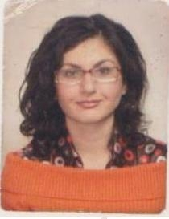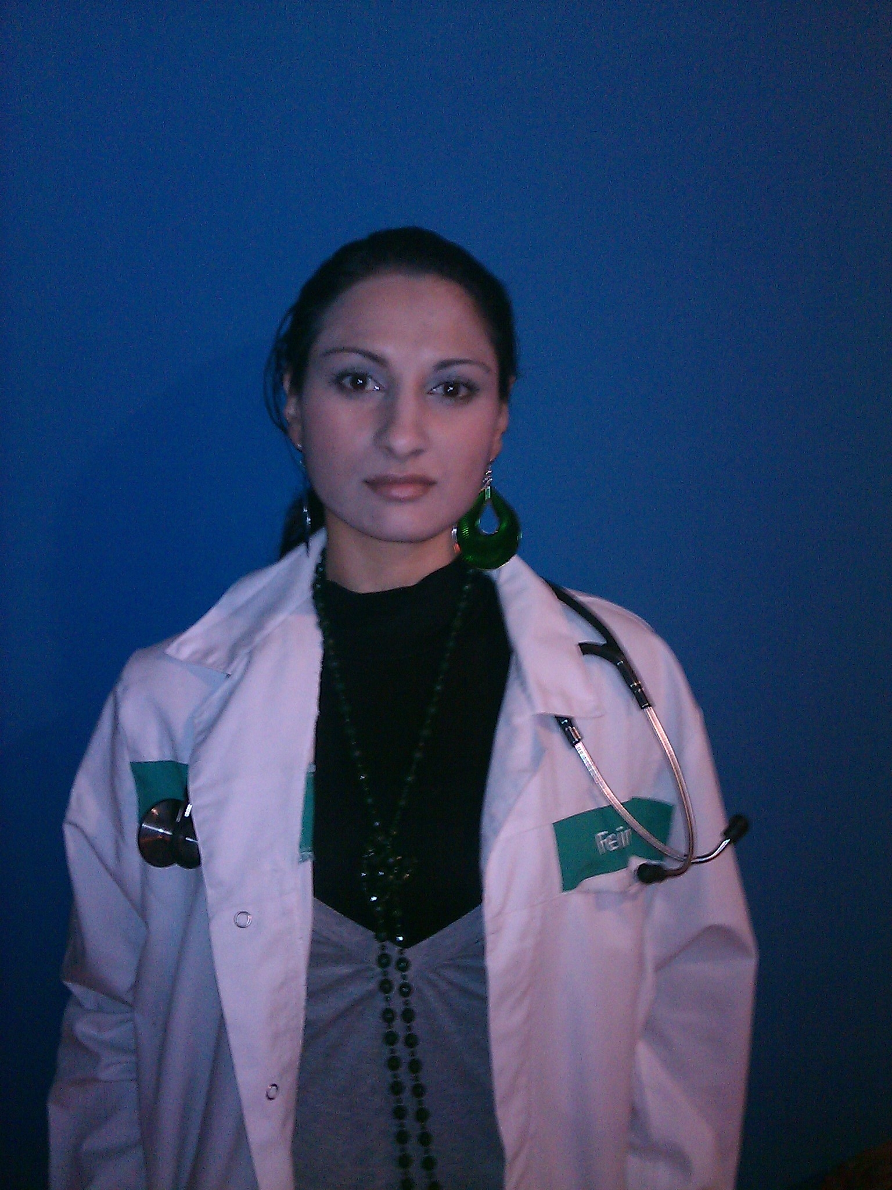

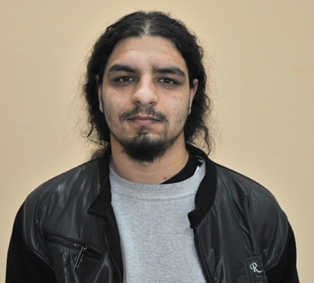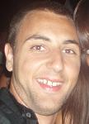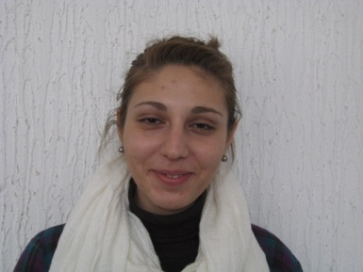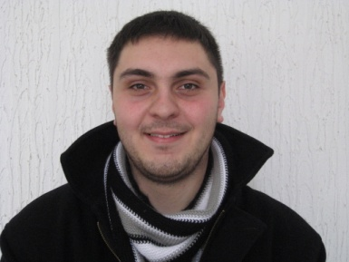

MENTORS:



