Faculty of Medicine Belgrade University Center School of Public Health
and Health Management

ROMA HEALTH PROJECT:
ROMA HEALTH SCHOLARSHIP PROGRAM – RHSP

MENTORSHIP COMPONENT

Final Report for the year 2014

The forth year of the mentorship component of the Roma Health Scholarship Program supported by Roma Education Fund (REF) was started on 1 December 2013 (oficially 12 December) and was completed on 30 November 2014. The whole project was implemented according to the project proposal approved by the Open Society Foundations. In total, 11 months (excluding one month of summer holiday from 15th July until 15th August) of intensive work at three university schools of medicine in the Republic of Serbia (Belgrade, Novi Sad and Nis) provided opportunity for Roma students and their mentors for better professional development and inclusion in academic community.
The main goal of this component was to provide one year mentorship program for Roma students preparing for health professions (medical doctor, pharmacist, dentist) at high educational institutions in Serbia. Only Roma students enrolled in Roma Health Scholarship Program and who got ghant by REF were eligible for mentoring.
Objectives of the mentorship component were to:
- Provide support and help for Roma students in their professional, academic and personal development;
- Support inclusion of Roma students in academic and social environment and realization of their right for education;
- Support Roma students in participation of health promotion programs devoted to Roma

communities and in development of effective public health policies for Roma health promotion.

ROMA STUDENTS IN THE MENTORING COMPONENT OF RHSP
In total 25 Roma students (Table 1) were involved in this project with 19 females and 6 males. Students were from three University centers: two of them from Faculty of Medicine Belgrade, 2 female students from Faculty of Pharmacy Belgrade, 13 of them from Faculty of Medicine Novi Sad and 8 students from Faculty of Medicine Nis. Unfortunatelly, this year we do not have students from the Faculty of Medicine in Kragujevac.
Although project started in December, we obtained the list of Roma students (preparing for health professions who received scholarships by REF, and thus became eligible for a mentor) not until 9 January 2014. REF Coordinator for Serbia, Jelica Nikolić sent on 24 February to the Head of the mentorship component of the project a final list of Roma students who got scholarships. From a total of 25, 18 students were from previous years of the project (2011, 2012 or 2013), while 7 of them were new students in the program. The majority were medical students (19), 6 pharmacy students and among medical students 2 of them are on special education program at the Medical Faculty in Novi Sad and one student in doctoral studies of public health also from Novi Sad.
At the very beginning of the project, students were introduced to their mentors and then carefully read and signed the Code of Conduct for students and mentors (Annex 1) in order to be aware in details of their obligations and mechanisms of arbitration in case of disagreement. During January and February all of them sent it to the project manager (2-3 Codes of Conduct were signed in March and April due to late call of freshmen who had a right for mentor but they were not in the project until then. The reason for that was a lack of information and technical errors in students' lists that were sent to the project manager). The formulation of the Code of Conduct came as a result of the experience in the first year of the project and of joint interview at the final meeting of the project held in Belgrade in November 2011. Usually one mentor was responsible for two Roma students, which is formulated by the requirements of the project, however, as some of the students were at special programmes and as it was an odd number of students at the Faculty of Medicine in Novi Sad, that rule could not be applied for six mentors,

and therefore they got one student each.

Student’s expectations from their mentors
All students involved in this project were obliged to write small essay (one page) about their expectations from the mentorship program which they later gave to their mentors and sent a copy to the project management team. They stressed primarily expectations from their mentors in terms of time devotion, listening and help. Students also expect help in learning process, easier curriculum management and understanding of their personal problems with advises how to overcome them, expect to establish good and friendly relationship and comunication with their mentors which will be supportative in hard times, provide them with feedback and assessement of improvement. Few students noted that they want help in scientific work – advice how to search literature, involvement in writing scientific articles and preparation for the meetings and congresses for their participation. Also, several of them expressed understanding and sympathy for the problems of Roma population in Serbia. It is very important that mentors were introduced with the expectations of their students, in order to be prepared for adequate responses during the mentorship program.

Student’s Personal Development Plan - PDP
As in the first three years of the project students were asked to make their own personal development plan (PDP) as a structured and continuous process that helps them to think about their own learning, performance and achievements and to plan for their personal, educational and career development. It is useful for students, as well as, for mentors. PDP presents a part of the

professional portfolio or educational file of both students and mentors. The role of the mentor is to help students to make their own PDPs which they will later fill in and maintain (through their study and career).
The primary objective for PDP is to improve the capacity of students to understand what and how they are learning, and to review, plan and take responsibility for their own learning. Also it helps them to define goals and to evaluate progress in achieving those goals, to become more effective and independent in their work, to improve the learning skills and to pursue positive attitude towards learning, future education and career.
In total 23 of 25 students in the forth year of the mentorship component of the project wrote their PDP. Unfortunately, two of them did not send their PDPs, despite numerous reminders (by e-mail and telephone) by the project manager.
PDP’s Template consists of 6 steps (Annex 2), and these are: current state definition, desired state definition, activities and resources needed to achieve the desired state, timeline, implementation and evaluation.
As a first step in the PDP, students defined their current state (Table 2), which was essential for measuring progress in the activities during the project life.
Regarding positive features, i.e. strengths, the students pointed out in the first place persistence and determination, i.e. devotion to set goals, than responsibility and ambition. They also see themselves as diligent, communicative, positive, intelligent young people. Some of them see themselves as unique, sociable and experienced. For the second consecutive year in the project the support of mentor was recognized as strength especially by students who had already been several years in the project indicating the importance of the mentoring process. Regarding weaknesses the most students emphasized on the first place lack of self-confidence and their hot- tempered nature, then their stubbornees and poor organization in teaching activities. Some of the students identified as negative features that they are uncommunicative, indecisive, with lack of motivation and emotional. Three of them said that they are self-critical and two that they are lazy. Concerning focus areas priorities on which they would like to work, i.e. to improve during the project life, in the first place is building of self-confidence and self-belief, than better management of their own time, emotional stability and patience, better communication, more

productive studying, more control over hot-tempered nature, as well as, more energeticity, emphaty and improvement of linguistic skills (Table 2).

Table 2. Students’ current state

WHAT ARE MY STRENGTHS? | WHAT ARE MY WEAKNESSES? | WHAT ARE THE COMMON FEEDBACKS THAT I RECEIVE FROM OTHERS? | WHAT ARE FOCUS AREA PRIORITIES THAT I NEED TO IMPROVE?
Persistent, determined (9)* | Lack of self- confidence (7) | Nice friend (6) | Building of self- confidence and self- belief (12)
Responsible, decisive (6) | Rash, Hot-tempered nature (7) | Witty, Happy (6) | Better management of own time (8)
Ambitious (6) | Stubborn (6) | Diligent, workaholic (5) | Emotional stability and patience (6)
Diligent (5) | Poor organizational skills (5) | Communicative (4) | Communicativeness (5)
Communicative (4) | Uncommunicative (4) | Persistent (4) | Efficacy, Productivity in studying (3)
Intelligent (3) | Indecisive (3) | Intelligent (3) | Control of hot- tempered nature (2)
Optimist (3) | Lack of motivation (3) | Disorganised (3) | Empathy (2)
Unique (2) | Emotional (3) | Good colleague (3) | Improvement of linguistic skills (2)
Sociable (2) | Self-critical (3) | Systematic (2) | Energeticity (1)
Experienced (2) | Lazy (2) | Responsible (2)
Mentor support (2) | Lack of foreign knowledge (2) | Creative (2)
*Total number of students who stated specific feature

As a second step in the PDP, students were asked to say what they wish to achieve and why, i.e. what are their objectives in the project and later in the lifetime. The greatest number of students in the first place said they want to gain better work habits in order to manage their time better, to be more relax in accomplishing their set goals, to plan their activities better, to be more efficient and more thorough in learning, to increase chances of getting the job, to be more successful and to have better social status. In the second place students underlined the desire to be more self-confident in order to be more satisfied, more open and more communicative. In third place they would like to learn more and to improve their knowledge (languages and computers) due to improvement and creation of themselves as future health professionals, to be better people and to be more respected in the society. Also they would like to be more decisive and self-confident and consequently not to be afraid to state their opinion and to create new opportunities for success. In fifth place of importance students would like to improve their emotional state in terms of being less sensitive and do not take too much to heart unimportant things as it will save them of unnecessary stress. Unlike in the first two years of the project, when most students saw themselves as members of non-governmental and student organizations through which they would like to promote the identity of the Roma people and to point out their marginalized position in the society, this year that was not the case cause in the meantime they have already become members of mentioned organizations. This also proved to be true when it comes to control of students’ hot-tempered nature which was present among some of them in the previous years. As a short-term goal, students would like at first place to pass remaining exams in the school year, to enroll in the next year and to be a little more occupied with out-of-school activities (learning languages and improving computer skills). Three of them would like to be more involved with volunteering and humanitarian work in certain NGO or student organization in order to help people who are in the need the most and primarily solve the problems of Roma community. Medium-term goals are to: obtain Bachelor’s degree and engage in scientific research work (projects, congresses, exchange of students). Regarding long-term goals, students would like to enroll in postgraduate studies (preferably abroad) and to see themselves as health professionals/specialists and proven experts in their field. Also, they would like to establish a stable family, to solve housing issue, to open own office and to constantly improve themselves.

Methods for meeting the goals, i.e. activities and resources which are needed for students in order to achieve the desired state are shown in Table 3.
This table clearly shows that students in the implementation of almost all activities recognize mentors’ help and see them as trustful personas which will help them to strengthen educational capacities due to better academic results, as well as personal and professional development. They are aware that scholarship is of exceptional importance and without it they would not be able to accomplish the majority of planned activities due to limited family budget.

Table 3. Activities and resources that students need to meet set goals

ACTIVITIES | RESOURCES
More active learning (make more efforts, to learn more, constant improvement and be better student) | Scientific literature, Internet (electronic journals, online life-coaching programs and seminars), contacts with mentors and other teaching staff, lectures, will, knowledge, educative workshops, grant
Better time management and planning of obligations | Planner, PDPs, mentor, will
To be engaged in scientific research (attend seminars, conferences, write scientific papers) | Scholarship, family budget, contacts with teachers, mentors, knowledge
Start volunteering and be more active in society | Own will, contacts with project colleagues who are Roma activists
To talk with mentor | Mentor
To travel | Contacts with teachers, mentors, scholarship, family budget
To be devoted to out-of-school activities | Time, scholarship, family budget, talent

The majority of students also defined timelines for achieving the desired state i.e. for meeting their set goals at the start of the project. They have already met a lot of them, which can be seen in more detailed scope from mentors’ report.
Students began with the implementation of PDPs in April 2014. They expressed satisfaction with PDPs which could be seen from the accompanying comments:
”As I honestly want to succeed in achieving my intentions and as I'm determined to firmly discipline myself and stick to the plan which I have made, I hope that I will be able to

achieve the goals I have mentioned”.
”Since I mentioned stubbornness as weakness in my previous personal development plan, I noticed that with regular stick to the plan I managed to partially overcome the difficulties involved in respecting the others opinion and consequently it was much easier for me to accept other people's views and opinions. I also examined the literature on communication skills and was interested in a seminar on communication, so with further work on the mentioned weakness I expect significant improvement. In the near future I plan to apply for scientific research that will give me the opportunity to perform in public and thus work on one of my weakness”.

Roma students evaluation of the Mentorship component of RHSP
Until 25 November 2014, inspite of repeted reminders, 13 students out of 25 returned filled evaluation questionnaire (52% response rate). It should be noted that the evaluation form was the same for both students and mentors in order to enable comparison of their answers (Annex 3).
The first group of questions were related to time spent with mentors, the quality of consultations and the fact who initiated meetings. According to their personal assessment, students spent in average ten hours per month with their mentors (minimum 1 hour, maximum 60 hours) including telephone and e-mail contacts. They all stressed that this amount of time was enough according to their needs, except one female student who stressed that time she spent with mentor was not enough. Most frequently, initiative for contacts was from both sides, two students answered that the initiative was from mentor’s side while three mentioned from their side.
The second group of questions refers to expectations, concerns and benefits gained from the whole mentorship component of the project. Student’s expectations were related to improvement of their professional and personal competencies, help in academic development and help in preparing exams. They also listed importance of help for easier learning, advices which help them in gathering new knowledge and skills, advices about lectures and exams and consultations with other teaching staff. Than, students expected to improve communication, networking with other teachers and professional development of academic networks. Their expectations were related to better adjustment to student’s life, easier overcoming of the

problems, psychological support and assistance in critical situations; gaining confidence and overcoming fear of exams; engaging in non-governmental organizations, as well as assist in scientific research work.
All students who completed the evaluation questionnaire responded that their expectations had been met.
Benefit gained from the program included both professional and personal aspects are listed in Table 4.
Most important professional benefits for students were: improvement of knowledge and expertise in the field of specialization, easier passing of difficult exams and learning efficacy, different learning approach, better time management, setting of priorities, different learning approach and more open approach in the communication with the teahing staff.
As personal benefits from the mentorship program they stressed building of self- confidence, support, personal identity and motivation. Following testimonies of the students illustate in the best way their personal benefits. One female student said: ”By holding the lessons to Roma elementary school pupils, I actually realized how hard was to be a mentor to someone and at the same time to be good at it. I hope to be a role model for them in the same way as my mentor is for me”, while one male student mentioned: ”It's easier when you know someone on the faculty whom you can contact and someone who will always be there when you need any kind of help”

Table 4. Professional and personal benefits for Roma students

PROFESSIONAL BENEFITS | PERSONAL BENEFITS
- Improvement of knowledge and expertise in the field of specialization  - Easier passing of difficult exams and learning efficacy  - Different learning approach, better time management, setting of priorities  - Cooperation with the professors and assistant professors without fear (more open approach) | - More self-confidence, support, strenghtening of personal identity and motivation  - ”By holding the lessons to Roma elementary school pupils, I actually realized how hard was to be a mentor to someone and at the same time to be good at it. I hope to be a role model for them as my mentor is for me”  - ”It's easier when you know someone on the faculty whom you can contact and someone who will always be there when you need any kind of help”

According to opinion of Roma students, majority of goals of the mentorship component were achieved, particularly those related to the fact that project enhanced the process of career development, increased their knowledge and enabled more contacts with colleagues and teachers. Also students think that the program assisted in developing career coaching skills for the mentors who participate in the program?
However, special attention deserves analysis of objectives which are only partly realized and related to the strategic direction for the career development of students (one student thinks that the program did not provide career strategy advice to the students), training for the skills necessary for daily practice sense of professional development (Table 5).

Table 5. Meeting the mentorship program component objectives by Roma students

QUESTIONS | NOT AT ALL | SOME - WHAT | NEEDS IMPRO- VEMENTS | YES
In your experience, did the program enhance the process of career development? |  | 1 | 2 | 10
Did the program provide (sufficient) career strategy advice to students? | 1 | 1 | 5 | 6
Did the program provide you with a sense of professional growth and development? |  | 2 | 4 | 7
Do you feel that the program assists in developing career coaching skills for the mentors who participate in the program? |  |  | 2 | 11
Did the program provide you with an opportunity to broader your knowledge and contacts with colleagues and teachers? |  | 1 | 2 | 10
Did the program expose you to different facets of practice in health care institutions? |  | 2 | 4 | 7

There were no remarks on the mentorship component of RHSP and majority of students stated that it was nice to have that project. For some of them mentors tasks should have been be defined more precisely and the project should have started earlier (beginning of the project paralel with the beginning of the school year). Also, they stated as a problem organization of summer school and annual meetings during examination period (their academic obligations’ overlapping with the date of venue).
When it comes to suggestions for improving the functioning of the project most advocated for earlier beginning of the project, that some mentors should devote more time to their students and to develop a joint project on which both students and their mentors should work.
Compliments of the project were very concrete and included the remark that the project made their studies easier, highlighting merits to the coordinator, mentors and funders for its implementation and special credits to some mentors as excellent educators. At the end illustrative quoted remark of one student: "I just want to say that I would be ashaimed to complain in general because I am very grateful that such project exists."

MENTORS IN MENTORSHIP COMPONENT OF RHSP
In January 2014 13 mentors were selected. After inclusion of additional RHSP students three more mentors were elected. For students who again received scholarships the selection of mentors was performed based on the evaluation of their work in the first three years of the project and expression of student’s desire to continue working with his/her mentor. For new students selection was based on the recommendation who would like to be their mentor and on communication with the colleagues from the faculties of health professions in Serbia.
Potential mentors filled application form with all important data and sent it later together with CV and short motivation letter with an explanation why they would like to participate in the project. Desirable characteristic such as openness, wilingness for cooperation and sensitivity to ethnic minority groups especially Roma people, motivation to help them to integrate more easily into the academic environment, and previous experience with the mentor were basis for selection.

Additional criterion for mentors’ selection was to teach in the same year their students registered because that way enabled mentors to help students in the learning process at their best. The limiting factor under the terms of the project was that a mentor has two students (so all students wishes could not be accepted).
From the previous project 13 mentors left: 8 from the Faculty of Medicine in Novi Sad, two from the Faculty of Medicine in Belgrade and three from the Faculty of Medicine in Nis. We thanked all other former mentors for cooperation (there was no Roma students for them).
In total 16 mentors were in the project this year (Table 6).
The selection process was based on the decision by project coordinator, assistant project coordinator and national coordinator of RHSP and completed by the second half of January and all mentors were informed about it.
Old mentors started with the work from the beginning of January. In the second half of January, newly elected mentors were introduced with their obligations in the mentorship component of the project, they were connected ("paired") with their students and it was recommended to organize the first meeting. All mentors and students signed the Code of Conduct in the project which specifies their responsibilities and mechanisms for arbitration in case of disagreement and submitted it during January, February and March to the project manager. Also, mentors and students were asked to make individual and collective digital photos in order to create publications and for the promotion of the entire project and its mentoring component. List of all mentors included in the mentorship component is presented in Table 6.
New selected mentors in the project based on mentioned criteria were:
Prof. Dr. Gordana Pešić, Faculty of Medicine Nis who was paired with one student
Prof. Dr. Mirjana Đukić, Faculty of Pharmacology in Belgrade, who was paired with two students
Assoc. Prof. Dr. Otto Barak, Faculty of Medicine Novi Sad, who was paired with two students
Professor dr Stojanka Arsić, mentor from the Faculty of Medicine in Nis and Assist. Prof. Dr. Boris Milijašević from the Faculty of Medicine in Novi Sad voluntarily accepted to work with other Roma medical students, who did not get scholarship but was willing to work with them. Project coordinator and assistant cooridnator organized meeting with Roma students

enrolled at the Faculty of Medicine Belgrade University based on affirmative measure of the Government of Serbia and offered them a help during their studies, but only two first year students Miloš Negić and Tamara Jovanović and one female student from Faculty of Pharmacology Belgrade were interested in the project and therefore informed about it.
It is worth to mention that mentors take care of their students from the previous project cycle who did not get a scholarship this year, but they are still in touch with the mentors.
During the whole period of project implementation, both students and their mentors had intensive contacts. Mentors regularly reported about all project activities, firstly bimonthly to assess how well they started their activities, after that per three months, and at the end of the project they submited final reports which were used also in the project evaluation. All mentor’s reports are part of the project documentation (on Serbian language) and are available on request.

Self-assessment of mentors – “How good mentor are you?”
One of the mentor’s tasks at the beginning of project implementation was to fill out a self-assessment questionnaire about their work, i.e. to have an insight to what extent they are good mentors for their mentees (Annex 4). All 16 mentors who participated in the project fill out mentioned form and submitted it to the project manager.
For each of 9 activities/strategies in self-assessment form, mentors were obliged to give an example from their practice which illustrates its use, as well as, to give suggestion for its improvement. Those activities include question about appreciation of individual differences among students, availability of mentors, use of active questioning which lead a mentee towards solution, strategy they use to build a scientific and social community with students, did they celebrate a student’s achievements, development of mentoring skills, networking and with how many of their past students they are still in contact.
All answers were similar to previous year thoughts of mentors taking in account that 13 of them are experienced mentors from the previous years of the project.
All mentors stressed that they appreciate individual differences among students and found it out as an important subject due to different students’ capacities for progressing and for fulfilling obligations (intelectual capacities), as well as, different approach towards learning and studying. They stressed a need for adjustment of the consultations to student’s needs and capabilities, their character and learning style. They also stressed that they have now more understanding and acceptance of differences among students, as well as they are more open in their approach to all students, not only those from ethnic minorities and they noticed that some students had problems in verbal communication and they tried to overcome it. When they were asked to give an example of doing this activity better or more, majority of them cited that probably more time for consultations and individual work would be useful, they are now more involved in activism against any form of discrimination and their lectures and exercises are more tailored to the needs of students and their level of understanding. Also regarding the fact that some of Roma students have stage fright before exam and public performance two mentors proposed organization of joint meetings (workshops, discussion on the topic "freedom in communication") aimed at overcoming mentioned issues.

Mentors said that they respect the agreed time of consultation and they require the same from the students, although consultation often happened before the exam or exercises. Mentors are available to their students at the faculties where face to face encounter can be easily arranged. Also, they can be reached by telephone, e-mail, and some of them through social networks, students’ forums or online consultations. They asked students to respect schedule of consultations, however as a problem they found lack of adequate space or rooms for direct consultations with their students.
Mentors usually questioned themselves about conflict situations with the students and tried to find adequate solutions. They also tried to incentivise students for better planning of their time and to motivate them for participation in scientific work. They said that better and more could have been done in finding the right motivation and encouragement of the students and to explore the causes of the problems they had like fear or anxiety during the exam.
Construction of the scientific community is a very important part of mentoring and therefore they stated to follow the interest of students and include them in teams engaged in scientific research, they recommended interesting books and publications or meetings and courses about research problems. When asked what they could have done better, they said better connections with colleagues who are engaged in scientific research (and potential connection of the students at Medical Faculty with the Center for scientific research work) and more incentives for students to be engaged in this kind of work, although it was not always easy considering how medical studies are difficult and demanding. One mentor think that it would be good to obligate students to be involved in scientific research work due to overcoming of unexcused barrier they possess, i.e. that science is unreachable for them.
When it comes to building social networks and community, mentors stimulated their Roma students to get involved in the Roma NGO and Students' Club, worked on the development of their social responsibility especially for the Roma people and their local communities, and encouraged students to participate in extracurricular activities – going out and having fun. Mentors believe that they had to encourage them more to work in NGOs and existing organizations at the Faculty (e.g. group aimed at promoting of social integration and inclusion through actions on health promotion, volunterism and work in health and social institutions), though it would have been better for Roma students to form their own social group focused on

specific tasks. Also they consider that more time should have been devoted to talks with students and other mentors about the ways of improvement of Roma social environment.
Talking about the remaining strategies that mentors practice in their work, it is important to note that they often celebrate the success of their students and with some of them are still in contact which represents a mentorship for life.

Mentors evaluation of the Mentorship component of RHSP
Project evaluation in this report is based on evaluation questionnaire filled out by mentors at the end of the project period in November 2014. The purpose of this evaluation is to determine whether the project justified invested money into professional and personal development of Roma students and whether it was tailored to their needs. Evaluation questionnaire (Annex 3) consisted of 12 questions divided into three groups.
Mentors sent completed questionnaire to project coordinator and assistant coordinator of the project who then analyzed the responses to the questions. Although it was anticipated that the questionnaire is anonymous, all mentors signed their names. It is particularly requested from mentors to give their comments and suggestions for project improvement in order to improve activities for the next year, to achieve better project results and to fit the needs of the students and mentors in greater extent.
All 16 mentors returned filled questionnaire by 15 November 2014 and evaluation results of Roma students and mentors were presented at the final meeting held at the Faculty of Medicine Belgrade University.
The first group of questions related to time spent with student, the quality of meetings and the fact who initiated meeting. Mentors spent in average from 6 hours monthly (minimum 1 hour and maximum 10 hours monthly during preparation for oral exams or test). All said that the time spent with the students was enough and adequate for student`s needs except one who considered that was not enough. The inition of the meetings usually came from both, but 6 mentors indicated that they were initiators of the meetings. An important note is that mentors noted less hours of consultation then students themselves.
The second group of questions from the evaluation questionnaire included expectations, comments and benefits from the project. All mentors noted that their expectation from the

project were fulfilled and they have no remarks on project organization, management and implementation.
Mentor`s expectations from the mentorship component are following:
  - Ability to learn more about the students and difficulties encountered during their studies and building of mutual trust as very important aspect of mentoring.
  - Mentors noted that this task was professional challenge for them, an opportunity for further professional development, for acquiring skills and knowledge which all leads to improvement of the pedagogical work of teachers at Faculties of health professions in Serbia.
  - Help students to better manage their time, commitments, to overcome stage fright and fear and to successfully pass exams and tests.
  - Introduction to the problems of Roma students during their studies, and
  - Cooperation and friendship with the students, striving for higher goals which are reflected in the proactive participation for the foundation of Roma academic elite.
The biggest professional benefit for mentors is the opportunity to improve their new pedagogical experience (acquiring of knowledge and skills) through mentoring, new individual approach in work with students and participation at international seminar dedicated to health care of Roma in Salzburg (for one female mentor). One mentor noticed:”The choice of me as a mentor build my reputation as a professor”.
When it comes to personal benefits they were related to high quality and more intimate contact with Roma students that enriched mentors with the special kind of emotions and offered them a better insight into own capabilities and new knowledge about Roma identity and culture (Table 7). The following statements depict in the best way personal benefits: ”Be more human, more tolerate, understand the problems of young students and be in the position to stay spiritually young” and ”I am more satysfied as a man, the project made me better person, more tolerate and patient in communication with the people”.

Table 7. Professional and personal benefits for mentors

PROFESSIONAL BENEFITS | PERSONAL BENEFITS
1. New and important pedagogical experience in mentorship, improvement of mentoring skills  - Participation at international seminar dedicated to Roma in health care - Salcburg  - New individual approach in work with students  - ”Roma students are not underrepresented in comparison to other students, so there is no room for any kind of prejudices and discrimination”.  - ”The choice of me as a mentor build my reputation as a professor”. | - ”Be more human, more tolerate, understand the problems of young students and be in the position to stay spiritually young”  - high-quality and more intimate contact, new friendships with the students,  - A better insight into own capabilities, a sense of significance, importance and nobility.  - ”I am more satysfied as a man, the project made me better person, more tolerate and patient in communication with the people”  - Valuable introduction to the culture and customs of the Roma community

The fulfillment of the mentoring program component objectives of the project according to mentors is presented in Table 8.

Table 8. Meeting the mentorship program component objectives by mentors

QUESTIONS | NOT AT ALL | SOME- WHAT | NEEDS IMPRO- VEMENTS | YES
In your experience, did the program enhance the process of career development? | 2 | 3 | 1 | 10
Do you feel that the program assists in developing career coaching skills for the mentors who participate in the program? | 1 | 1 |  | 14
Did the program provide (sufficient) career strategy advice to students? |  | 1 | 6 | 9
Did the program provide you with a sense of professional growth and development? | 1 | 2 | 2 | 11

In your opinion, does the program provide mentors with greater appreciation of their significance as role model? | 1 |  | 1 | 14
Did the program provide you with an opportunity to broader your knowledge and contacts with colleagues and teachers? |  | 3 | 2 | 11
Did the program expose you to different facets of practice in health care institutions? | 4 | 3 | 3 | 6

According to mentors’ opinion, this component was very important for development of mentoring skills; provide them with greater appreciation of their significance as role model, with a sense of professional growth, helped them to improve knowledge and also their contacts with other colleagues at universities. They also stressed involvement in this project as important for their career development and provision (sufficient) of career strategy advice to students. However, like in the last year, mentors` opinion is that the project met all objectives except enough exposure of students to different facets of practice in health care institutions.
Many useful suggestions and comments were given by mentors how to improve project performances. Suggestion from mentors related to the beginning of the project with the school year due to better monitor of student’s work and the fact that the beginning of school year is the most critical period of adaptation for all students (it was also suggestion from last year), but unfortunately this was not possible to realize because of duration of student’s application and selection procedure of RHSP beneficiaries. They stressed the need for multiple contacts, especially those who are new in the project because they are not familiar enough with their students. It would be important for them to have roles of their students exactly defined cause some of Roma students expect from mentors to study with them and not to give simple guidelines. One female mentor stated as a remark to the project team that the students who lost year and consequently RHSP grant are not followed and left at their own which is quite opposite with the activities of the management team. Every year old RHSP students and students enrolled at the Faculties through affirmative measures are invited to be a part ot the project cycle. The

main problem is a fact that very small number of them respond to our call.

Recommendations for project improvement:
  - More frequent meetings of students and mentors in order to get know each other better and for exchange of experiences and also more contacts among mentors;
  - Providing financial support for independent student projects;
  - Giving of the concrete task that mentor or student need to do, define roles clearer
  - Following of the students after losing a year would reduce the dropout rate and enable them easier come back at the Faculty;
  - Forming of mentoring tandems at the first year of studies (mentor teacher and mentor student of Roma nationality who was or is a RHSP beneficiary in order to reduce gap in years and to help them to get accustomed to new surroundings);
  - Introducing of periodical evaluation of mentors and students about the quality of their interpersonal relationship;
  - Establishing of the relationship between mentors and Center for scientific research work of students with the aim to include students in scientific work enabling them better position in the future while searching for a job
Finally, as a conclusion it was stated that the project is well designed, its realization constantly monitored and that extraordinary relationship between management team and mentors and students is established. It provides students with the opportunity to improve their knowledge and skills, gain self-confidence and appreciate their own values. It was stated that the project is a major step forward improved professor – student relation in undergraduate studies at the Faculties of health professions in Serbia. One mentor said, "I think that this is the right way for the integration of ethnic minorities in the society by mutual respecting und understanding", while the other noted: "The project was made up at high professional level. The big advantage/value of the project is the constant monitoring of the realization of set goals. The pillars of the project are with no doubt, its coordinators Snezana and Janko who are always at stand-by for us. Thank to them everything functions well and their devotion takes all credits".

ACTIVITIES IMPLEMENTED IN MENTORSHIP COMPONENT OF THE RHSP DURING 2014
During the project implementation in 2014 cooperation with other components of the RHSP – advocacy component and media component was established and it was very close and successful. Also many activities related to the organization of meetings of the mentorship component of the project, as well as, to the participation at meetings and conferences that are directly or indirectly associated with RHSP were organized.

Organization of mentorship component meetings on the beginning and at the end of the project implementation in 2014
The first meeting of Roma students and their mentors was organized on 3 April in the premises of main building, Faculty of Medicine Novi Sad University (Hajduk Veljkova 3, in feast hall of Deans’ building on the first floor). This was according to the suggestion from Roma students and mentors to change place of meetings and to allow other Faculties to provide hospitality for the project. Originaly we wanted to organize meeting in Nis but despite our good will, due to lack of organizational capabilities of employees at Medical Faculty of Nis, the meeting was organized in Novi Sad again (two consecutive years). The majority of Roma students and mentors participated at the meeting with project coordinator and assistant project coordinator. Dean, Prof. Dr. Nikola Grujić welcomed guests and then mentor Prof. Dr. Ljubica Stojsic Dzunja as host and representative of mentors from Novi Sad University talked about her mentoring experience and work with her students. Project coordinator Assoc. Prof. Dr. Janko Janković had a presentation on the topic of "Mentoring, roles of mentor and personal development plan for the students in RHSP program" in order to meet new students and new mentors with the characteristics of this component of the project and with obligations, while the assistant project coordinator, Prof. Dr. Snezana Simic participants introduced the present with the students expectations in the project. Then the discussion between students and mentors (devided into two focus groups) about achievements, disadvantages, lessons learned and planned activities came after. Promotional Bulletin about the work during the third year of the project was distributed to all interested participants. After the meeting cocktail lunch was organized at the restaurant of the Medical Faculty in Novi Sad.

This meeting was beneficial for all participants in the project since this year there was no Winter School. They had the opportunity to be for the first time all together, to meet eachother a little bit more, to exchange their experiences and to plan future obligations more realistically.
Unfortunatelly no one came from the Belgrade Open Society Foundation and Roma Education Fund.
The second and final meeting of Roma students and mentors was organized almost at the end of the project year, on 26 November, in the premises of Dean’s building, Faculty of Medicine Belgrade. The meeting was not attended by all students and mentors, as some were sick or prevented to come due their obligations. Also Roma RHSP old beneficiaries and students enrolled at the Faculties in Belgrade through affirmative measures were invited but only one Roma female student enrolled at the Faculty of Pharmacy in Belgrade through affirmative measure joined us. The guests were welcomed on behalf of the Faculty of Medicine by Vice Dean for integrated studies of medicine (Prof. Dr. Tanja Jovanovic), then Vice Dean for Continuous Medical Education (Prof. Dr. Vesna Bjegovic) and at the end by Head of the Centre School of Public Health and Health Management (Prof. Dr. Dejana Vukovic). Unfortunatelly no one came from Belgrade Open Society Foundation and REF due to their planned activities in advance. Project Manager Janko Jankovic talked about the "Evaluation of the project from the beginning of its implementation (2010-2014)", and the Depute Project Manager, Snezana Simic introduced the participants with the "Programes intended for Roma population in Serbia". Then discussion about the results of the project and suggestions for its improvement came alive (two focus groups). Bulletin about the work in this year project was distributed to all attendees. At the end, we all hung out together for a cocktail lunch at the Institute of Social Medicine (building across the Dean’s Building).

Meetings of the project management team with mentors and students from the University of Belgrade
At the Institute of Social Medicine on 7 March and 3 October two joint meetings of mentors and students from the University of Belgrade were organized in order to better meet each other and to talk about any kind of isssues. From the Faculty of Medicine in Belgrade besides project manager, deputy project manager and secretary mentor Dr. Zeljka Stanojevic and

students Damir Bahtijarević and Tamara Savu attended both meetings. Mentor Prof. Mirjana Djukic from Pharmacy Faculty with her both students (Eva Grubnic and Vanja Trkulja) was present. We also called the former RHSP benefitiaries and all Roma students who were enrolled this year and previous years at the Faculty of Medicine Belgrade over affirmative measure but no one responded. After second meeting coctail lunch was organized at the Institute of Social Medicine (colleagues from the Institute were also present).

Cooperation with Advocacy component of the RHSP
Like every year winter school "Sasto III" – Advocate school for Roma future health care professionals was planned to be held in Andrevlje, Fruska Gora under the auspices of the Association of Roma Students from Novi Sad who are in charge of advocacy component. Unfortunately that did not happened and the new date for mentioned activity will be in March 2015. Like in the previous years the management team of the mentorship component will have oral presentations.

Cooperation with Media component of the RHSP
Cooperation with the media component of the project during the entire project period was continuous.
In May 2014, project coordinator and deputy project coordinator participated in series of meetings (press conferences) around Serbia devoted to promotion of the project results and its components. Media are introduced with the results of four year’s realization of the project and with the importance of program support for education and enabling of better life for Roma minority members. Promotion meetings were organized in Belgrade, Novi Sad, Subotica, Kragujevac, Nis and Vranje. Beside coordinators of all project components, usually in every city, Roma students presented their experience with the project. That was at the same time an opportunity to talk with them about issues regarding mentorship component and also to recommend some new activities to representatives of other project components.
After promotion meetings media component finished their project, but cooperation is still continuing.

Annual meeting with RHSP partners
The Head of the mentoring component, Janko Jankovic participated in the annual meeting of the "Partners scholarship program for education of Roma in health professions" held in Snagov, Romania, 16 and 17 July 2014. Also one representative from each component of the RHSP participated from Serbia, as well as, former RHSP beneficiary Violeta Micic who spoke about her experiences in the project.
Janko Jankovic in the panel discussion "RHSP changes and flexibility in 2013-2014 academic year" dedicated to mentoring and advocacy components talked about the undertaken measures for the fulfillment of the recommendations (set at the previous annual meeting in Sinaia) due to more high-quality and more effective work on the mentorship component, as well as, achievements, challenges and lessons learned from the mentoring component of the project. Experiences were exchanged with colleagues from neighboring countries (Macedonia, Romania and Bulgaria) where similar projects are in progress for several years and therefore their ideas and activities will be helpful for improvement of the mentoring component in Serbia. Meeting and socializing after were constructive and beneficial for all partners in the project. Publication guide for mentors were distributed to all stakeholders, as well as the promotional Bulletin about the third year of the project in Serbia.

Other activities
From 10 to 12 April, the project manager participated at the European conference on migrant and ethnic minority health in Granada, Spain, where he had oral presentation of the abstract on reproductive health of Roma women (available on request).
From 27 to 29 October, deputy project coordinator participated at the expert symposium at the European level entitled "Healthy aging of Roma communities - Reality and Perspectives".
Expert Symposium was held at the Medical Faculty University of Pecs, Hungary under the auspices of the WHO European Region and the State Secretariat for social issues and social inclusion of the Hungarian government. The meeting was organized by Professor Istvan Szilard from the Medical Faculty in Pecs and department of health and health care of migrants. It was attended by 30 professionals involved in the implementation of programs targeting the Roma in the region. On behalf of WHO, the symposium was attended by Piroska Ostin - manager for

health care programs for vulnerable social groups and Manfred Huber - program coordinator for healthy aging, disability and long-term nursing and care.
During the two-day meeting the existing programs for the Roma population in Central Europe and the Balkans were extensively discussed, and also the ideas and proposals for new programs were considered. Visits were organized to Roma villages in Hungarian Baranja - one of the poorest districts of Hungary, where the participants of the symposium were able to familiarize themselves with some interesting EU programs for Roma, as well as, with the organization of health and social care for this population group. The most current programs were presented, so that the participants could perceive their importance and were introduced with their main characteristics.
At the Medical School of Pecs two new master programs were presented that have been developed in the framework of EU projects in collaboration with Universities in Germany and the Netherlands. These are master programs on cultural diversity and competences and on migrants’ health, which are planned to start in the next school year after approval of the EU.
The whole symposium was extremely interesting and stimulating for the development of new programs for vulnerable groups, particularly for the Roma population.
During the month of November promotion Bulletin on project activities was printed in Serbian and English languages and distributed to students and mentors at the final meeting in Belgrade.

Meeting on the sustainability of RHSP
Although the project officially ended on 1 December, it is important to note that representatives of all components of the RHSP project on 3 December participated in a meeting with Sofia Djukic, deputy head of TEMPUS-ERASMUS+ office in Belgrade. The meeting was organized by the project manager on the proposal of the Association of Roma Students from Novi Sad regarding the sustainability of RHSP programe under TEMPUS as EU financial instrument for the reform of higher education.
The good news is that mentorship, media and advocacy components are eligible for funding under TEMPUS-ERASMUS+. The bad news is that the target group should be expanded

with other categories of vulnerable students, such as students with disabilities, single parent students, students with the status of internally displaced persons and students from poor families. Also, TEMPUS criteria related to the number of countries and the number of higher education institutions / partner institutions can be an obstacle for financing RHSP under the TEMPUS - ERASMUS + instrument. This instrument requires that more countries need to be included, as well as, more institutions of higher education. The problem is that in all three countries where RHSP program is being implemented (Macedonia, Bulgaria and Romania) except Serbia, NGOs are in charge of the mentorship component and the applicant and key
partners must be higher education institutions.

National Board for the selection of RHSP beneficiaries
This year, like in the previous two Janko Jankovic took part in the National Board for the selection of RHSP beneficiaries who will participate in the fifth year of the mentoring component of the project. During the ten days of July (3-13), candidates were evaluated over the internet, i.e. their essays, intention and recommendation letters, as well as, their extra-culicular activities. In total 31 potential beneficiaries applied (high school pupils and students). On 14 July over Skype all members of the Board met to overcome the differences in the assessment of some candidates.

Gala reception for beneficiaries of Roma Education Fund (REF)
Professor Snezana Simic, as deputy project manager attended the gala reception for beneficiaries of Roma Education Fund, held at the National Bank of Serbia on 28 November 2014. The reception was attended by Roma students from the Faculties of human and natural sciences from all over Serbia while students who are studying for health professions were not invited to this event. The moderator of the event was Jelica Nikolic, coordinator of REF for scholarship programs in Serbia. Beside her, Doghi Day – REF program manager for higher education and Anastaytayia Nagy – REF referent for Serbia, both from Budapest had their speeches, as well as, Zeljko Jovanovic - Director of the Office for Roma Initiatives of the Open Society Foundation in Budapest. Two students from Nis who are REF beneficiaries presented

their experience and their life path until the enrollment at the University and stressed the importance of scholarships for their training.
In the part of the ceremony regarding the questions and comments of students, the largest number of questions related to the requirement to pass the half of all exams in the school year for which the scholarship was received, a condition that does not respect the specificities of studying at some Faculties and takes no account of the quality of studies (grade level). Reply of REF officials was to try to be flexible and to take into account the specificities of studying after detailed explanations by the student but they will not give up from this requirement.
There were objections by the program coordinator about the gravity of communication with the students, as they irregularly read and do not reply e-mails, so it was recommended to be more efficient in communication. The recommendation is also to introduce other methods of communication with the students: facebook, twiter, instagram, as well as, to be used Alumni Yahoo group that already exists and that brings together REF scholarship holders.
The ceremony was well covered by media with a lot of reporters, TV cameras and photographers.
Lessons learned for our project:
- Establish a group of University students from the RHSP project on facebook and twiter and improve communication with them.
- Provide media promotion and visibility of mentorship component, particularly bearing in mind that the media component of the project does not exist this year and due to the 5th project year
- Invite on our closing ceremony all mentors and all students and provide them with the certificates.

BASIC PROJECT INDICATORS
All basic process and outcome indicators listed in the project proposal were selected from mentor’s reports submitted by mentor. Some of them were selected from evaluation questionnaire filled out at the end of the project period by students and their mentors. Also, other project documentation – checklists, diaries, presentations were used for calculation of indicators (Table 9).

Out of 25 Roma students in the mentorship component, 19 of them passed all necessary exams and enrolled at the next year of study (one female student is at postgraduated studies in public health, II year; two are candidates for a degree and one obtained MD degree), which is a significant success of students and their mentors. Seven students have a very high average mark (over 9) and they are excellent students. Also, four students are actively engaged in scientific research work of whom one presented scientific paper at the national student congress/symposium and some of them are currently writing papers and are preparing to participate next year. 10 of them are very active in the work of Roma non-governmental and students organizations in their cities.

During this year Bulletin was printed for the promotion of the project and presented to both students and mentors at the final meeting in Belgrade (Annex 5) in both Serbian and English languages.
Values of the indicators for monitoring mentorship component results are presented in table 10.

Table 10. Student’s success during mentorship component implementation in 2014

INDICATORS | VALUES
1. Number of students who completed academic year and enrolled into next | 19 out of 25 (2 candidates for degree, one female student at postgraduate studies and one obtained MD degree)
2. Success of students measured by number of exams passed and average mark | In average passed almost 6 exams  (5.9 precisely; min 0 – max  11)

 | Average mark in the range 6.3 – 9.6
3. Number of students who wrote paper for medical journals | 1
4. Number of students who wrote abstracts and participated at students national and international congreses | 1 (female student from Nis)
5. Number of students active in Roma NGOs or in Roma communities | 10
6. Number of students who got Erasmus grant | /
7. Number of students who got Basileus grant | /
8. Number of students who will stay in program | We do not know yet

THE MAIN OBSTACLES AND ISSUES
Some of the students who received RHSP scholarship were included later in the mentorship component (February-April) because tables with this year RHSP grantees were with lack of data and with mistakes and therefore they were not contacted on time. First year students were informed by their colleagues about the right for a mentor so they got in touch with me. The problem is in their online applications (students who are not entitled as students) and in received tables (data error and lack of data). The same problem was in the previous year and the project manager informed Jelica Nikolic.
Majority of the students still don’t have a culture of e-mail correspondence despite our insisting on that and constantly pointing out on its importance. Consequently some of them do not send at all or do not send on time the requested documentation (they are reluctant to reply).
The project management team believes that students are not using sufficiently scholarships for foreign languages, as well as, grants for participation at international conferences although they were introduced with all benefits of such. This year, no one applied for the mentioned scholarships.
The mentors were asked to state explicitly all possible problems in work with the students, but also to specify precisely which exams their students passed and which did not to make it easier for both mentors and project management team to track students’ development and progress. There is a problem with two female students (Martina Ismanović i Keti Sulejmani) who suddenly stop their contacts with the mentors and withdrew from Faculty. Student Jelena Firic also was out of reach from September and did not contact her mentor who at the end via student office realized that she failed academic year. The project manager was trying to get in touch with

them but there are no positive results. He also informed REF coordinator for RHSP Serbia Jelica Nikolic.
Some students had health and family issues, and one student has been maintaining pregnancy (which did not lead to a break in the passing exams because she is at postgraduate studies and is writing doctoral dissertation) and therefore mentors and students invested extra effort to overcome these obstacles. Also, two students were in the prolonged training abroad (Sonja Bulatovic and Slobodan Maricic) which included missing of few examination periods.
During the meetings in Novi Sad and Belgrade discussion was organized with mentors and students in two separate focus groups.
Mentors identified several problems in their work:
- Roma students are expecting from mentors to learn with them and not to give them guidelines and clarification of certain fields
- It is extremely difficult to include Roma students (and not only them) in scientific research, mainly because of the huge obligations they have during the studies, and partly due to the inability to recognize the importance of research. However, the best Roma students are involved in the projects, writing of papers and participation at the student conferences and congresses
- One Roma female, candidate for PhD degree in public health, particularly highlighted problems in the writing and publishing of papers due to lack of financial resources
- Special problem are individuals who cannot cope with certain items and therefore lose a year and scholarship. It would be good to help them by organizing consultations and maybe to allocate certain amount of financial means for the teachers to hold additional classes to those students; it would be also important to determine how many students drop out or stop their studies in a given year when they cannot pass an exam. When they lose their scholarships and are no longer in the mentoring program they are lost and they need help the most.
Students also pointed out several issues:
- Mentorship process should follow the academic year, not calendar year and thus mentors help would be available to students was at the beginning of the academic year (at the end of September and in the first half of October), when they need the most, especially for freshmen

- Usually dates are not suitable for activities within RHSP (Winter School, RHSP regional partnership meeting) because students have a lot of exams and consequently some do not attend mentioned activities
- 28 February as the deadline for sending transcripts of exam marks to REF should be changed and semiannual report on all activities should be accepted and not to look only exam marks as a criterion for payment of the second installment of student scholarships because some exams can only be passed in the second semester. This year, several students lost the right to the second part of the scholarship and thus become demotivated to continue their studies (allegedly one female student from Nis withdrew form the Faculty because of it)

SUGGESTIONS FOR MENTORSHIP COMPONENT IMPROVEMENT
Suggestions for improving the mentoring component of the project given by Roma students and their mentors in the evaluation questionnaire and during the meetings are as follows:
  - Most insisted that the project should start with the beginning of the school year because it is the most critical period of adaptation for all students, especially for Roma.
  - Mentors said that it would be good to provide financial support for independent student projects.
  - Mentors highlighted the need for more contacts/meetings, especially those who are new to the project because they are not familiar enough with their students. It would be important to define more precisely the skills of their students (like presentation skills and public speaking skills) and to define roles clearer.
  - An interesting proposal was initiated by an older mentor regarding the help of older Roma students to younger ones (newly enrolled) and obliged older students to take care of one Roma student and help him to find his way and inform him about the most important aspect at the faculties (problems and benefits). Forming of mentoring tandems at the first year of studies would be a challenge (mentor teacher and mentor student of Roma nationality).
  - Special challenge is to engage students in other activities and encourage them to do sports, music and folklore. Mentors feel that this would help them to better integrate into

the academic environment and to be more relaxed and stimulated for difficult and hard work during their studies of medicine, dentistry and pharmacy
Anyway, as it could be seen from the analysis of the project evaluation by students and mentors, all are satisfied with the organization of the project, with the results' monitoring and the activities carried out and they believe that this program is of great importance for their personal and professional development.

CONCLUSION
It is important for whole education system in Serbia to become more open to multicultural approaches and for people to accept the fact that by belonging to other nationality or to minority does not mean being exactly the same, having the same cultural diferences, or having the same economic background as it stressed in position paper of the Roma Education Fund „Roma Inclusion in Education“ (2010).
Throughout the whole 2014 the mentors have been working intensively with their students. Activities in this component of the project were devoted primarily to consultations, mastering the curriculum and way of passing the exams. Mentors reports (two-month and three- month reports) show that mentors intensely held consultations and follow the progress of their students. Also in contact with their colleagues they tried to give students some clarifications or elaboration of some difficult areas and to encourage them in their studying efforts.
The intention of the project management team was the constant inclusion in the process of mentorship Roma pupils and students who did not get REF scholarships (also those enrolled in medical schools by using specific affirmative measures).
All RHSP activities are recognized in the academic community of Serbia, more and more students are involved in this program, more mentors are interested to participate in it and those involved in the project unselfishly help Roma students to achieve better results. Also the number of Roma students who are enrolled through affirmative measure at the Faculties of health professions is increasing which indicates that the academic community has become more sensitive to their needs and expectations from the society. Finally, as in the three previous reports, it should be stressed that whole RHSP and its mentorship component provide significant contribution to the process of Roma inclusion in high education. The impact of good mentor

goes far beyond his or her own boundaries. With improvement of mentors’ skills and students’ compliance with this component of RHSP, as well as, with wider promotion and acceptance of this program by Roma community, we can expect better participation and better results in years to come.

Belgrade
31. 12. 2014.

Annex 1.

KODEKS PONAŠANJA I RADA STUDENATA I MENTORA U PROJEKTU
„MENTORSKA PODRŠKA ROMIMA STIPENDISTIMA KOJI SE ŠKOLUJU ZA ZDRAVSTVENE PROFESIJE“

Ovim Kodeksom su definisane obaveze mentora i romskih studenata u projektu
„Mentorska podrška Romima stipendistima koji se školuju za zdravstvene profesije“ kao i mehanizmi arbitriranja u slučaju nesporazuma ili problema u radu. Mentor/mentorka će zajedno sa romskim studentima/studentkinjama svojeručnim potpisivanjem ovog dokumenta potvrditi da su upoznati sa obavezama i da će ih se pridržavati tokom trajanja projekta. Potpisan Kodeks bi trebalo vratiti rukovodiocima projekta (profesorki dr Snežani Simić i asistentu dr Janku Jankoviću).

- Očekuje se da se tokom projekta mentor/mentorka viđa sa svojim studentima jednom nedeljno „licem u lice“ (4 do 6 puta mesečno), a da istovremeno održavaju i druge vidove komunikacije, telefonom ili imejlom. Tokom ovih konsultacija, oni razgovaraju o napredovanju studenta na studijama, pripremaju ih za polaganje ispita, kolokvijuma i seminara tako što im omogućavaju kontakte i sa drugim nastavnicima ili saradnicima u nastavi i rešavaju eventualne probleme koji mogu da se pojave tokom studija.
- Odnos mentora/mentorki i romskih studenata/studentkinja je odnos pun razumevanja, poštovanja i uvažavanja međusobnih razlika. Studenti i mentori poštuju zakazano vreme konsultacija, kao i druge obaveze koje su preuzeli tokom međusobnog dogovora. Mentori i studenti su obavezi da redovno komuniciraju sa rukovodiocem projekta i zamenikom rukovodioca projekta (da odgovaraju na imejl poruke i/ili telefonske pozive).
- Na samom početku projekta je potrebno da mentor popuni upitnik za samoprocenu “koliko sam dobar mentor“, da ga pošalje rukovodiocu projekta, kao i da radi na usavršavanju svojih mentorskih veština.
- Od romskih studenata i studentkinja se očekuje da na početku projekta napišu kratak esej (na jednoj strani) o svojim očekivanjima od ovog projekta.

- Mentor/mentorka takođe ima obavezu da sa svojim studentima/studentkinjama u prvom mesecu rada na projektu formuliše personalni plan njihovog razvoja na osnovu formata koji je preporučen i usvojen u ovom projektu i koji će im biti dostavljen. Realizaciju ciljeva personalnog plana razvoja potom zajednički prate.
- Mentor/mentorka pomaže studentima/studentkinjama ako su zainteresovani za naučno- istraživački rad tako što mu lično, ili u saradnji sa drugim kolegama, pomaže u izboru teme, pretraživanju literature, kritičkom čitanju literature i pisanju studentskih radova. Potrebno je romske studente i studentkinje stimulisati i motivisati da učestvuju na kongresima studenata medicine i stomatologije sa tim radovima ili da ih publikuju, da konkurišu za domaće i međunarodne stipendije, i da usavršavaju znanje jezika (posebno engleskog jezika).
- Od mentora/mentorki se takođe očekuje da romske studente i studentkinje stimulišu da se angažuju u radu nevladinih organizacija, posebno onih koje se bave unapređenjem zdravlja Roma u Srbiji.
- Svi mentori i svi studenti u ovom projektu imaju obavezu da prisustvuju i učestvuju u radu sastanaka koji će biti organizovani na početku projekta (prva nedelja marta meseca) i na kraju projekta (poslednja nedelja novembra meseca) na kojima će se razgovarati o načinu rada na projektu, dostignućima i problemima u radu. Posle prve polovine projekta, mentori/mentorske i romski studenti/studentkinje popunjavaju evaluacioni upitnik, kao i na završetku projekta. Tokom projekta će biti organizovan monitoring rada mentora/mentorki sa romskim studentima/studentkinjama.
- U slučaju da se pojave problemi u radu mentora i romskih studenata, na zahtev studenta ili mentora može doći do promene mentora sa obrazloženjem zašto se to radi i nakon pokušaja da se međusobni problemi ili nesporazumi reše.

Datum:

Asis. dr Željka Stanojević, mentorka Tamara Savu, studentkinja

Annex 2.
Personal Development Plan Template

What is my current state?
What are my strengths? | 1.  2.  3.
What are my weaknesses? | 1.  2.  3.
What are the common feedbacks that I receive from others | 1.  2.  3.
What are focus area priorities that I need to improve? | 1.  2.  3.
What is my desired state?
What do I want to improve? | 1.  2.  3.
Why do I need that? What does it give me? | 1.  2.  3.
What are my short-term goals (up to one year)? | 1.  2.  3.
What are my medium-term goals (2-5 years)? | 1.  2.  3.
What are my long-term goals (up to 10 years)? | 1.  2.  3.
What is needed to achieve desired state?
What activities do I need to take for achieving the goals? | 1.  2.  3

What are the possible resources for achieving the goals? | 1.  2.  3
Timeline
Schedule of activities | Focus area 1  Day and time:  Focus area 2  Day and time:  Focus area 3  Day and time:
Deadline for achieving the desired state? | Focus area 1  Start date:  Short-term goal: Medium-term goal: Long-term goal:  Focus area 2  Start date:  Short-term goal: Medium-term goal: Long-term goal:  Focus area 3  Start date:  Short-term goal: Medium-term goal: Long-term goal:
Notes/comments/suggestions/other

Annex 3
MENTOR / STUDENT EVALUATION FORM

To help RHE fund to maintain and improve the Mentorship component of the RHSP, we request that you complete and return the following program evaluation form. Please return filled questionnaire electronically to рrofessor Dr. Snežana Simić (snezanas@eunet.rs) or to assistant professor Dr. Janko Janković (drjankojankovic@yahoo.cоm).

This evaluation is being completed by the (check one):
а) Student b) Mentor

Name and surname (optional):

- Howmuch time, on average, per month has you spent with your mentor/student?
(in hours)
How was it spent?

- Did this time commitment suit your needs? YES NO

- If answer is NO, it was: a) too long, or b) too short

- Which one usually initiated the meetings?
а) Mentor b) Student c) Both equally

- What expectations did you have from the program?

- Have these expectations been met? YES NO

- If answer is NO, way is that?

- Do you have any concerns about the program? (Please give examples and explain)

- What do you feel you have gained from this program?

а) professionally

б) personally

- Please rank you answer for each question. Additional feedback is welcome and can be submitted on separate sheet provided at the end of this evaluation form.

QUESTION | NOT AT ALL | SOME- WHAT | NEEDS IMPROVEMENT | YES
1. In your experience, did the program enhance the process of career development?
2. Do you feel that the program assists in developing career coaching skills for the mentors who participate in the program?
3. Did the program provide (sufficient) career strategy advice to students?
4. Did the program provide you with a sense of professional growth and development?
5. In your opinion, does the program provide mentors with a greater appreciation of their significance as a role model?
6. Did the program provide you with an opportunity to broader your knowledge and contacts with colleagues and teachers?
7. Did the program expose you to different facets of practice in health care institutions?

- Please give suggestions on how to enhance the program.

- Please add any additional comments you may have. Thank you for your assistance!

Annex 4.
SELF-ASSESSMENT: How good mentor are you?

ACTIVITY / STRATEGY | QUESTION / TASK | EXAMPLE | WHAT COULD BE DONE BETTER?
Appreciate individual differences | Give and example of an incident that illustrates your acknowledgement of individual difference
Availability | Give and example of the strategy you use to be available to your students/staf
Questioning | Describe how you last used active questioning to leed a mentee towards solution
Building scientific community | Describe a deliberate strategy you use to build a scientific community in your group
Building social community | Describe a deliberate strategy you use to build your group as a social community
Celebration | When did you last celebrate a student/staff member’s achievements? How did you celebrate?
Skill development | Describe steps you take to develop the critical writing and presentation skills of your students/staff
Networking | Describe one example of how you have introduced each of your students/staff into the scientific network of your research area
Mentor for life | How many of your past students/staff are you contact with?

44

Annex 5. Mentorship component Bulettin
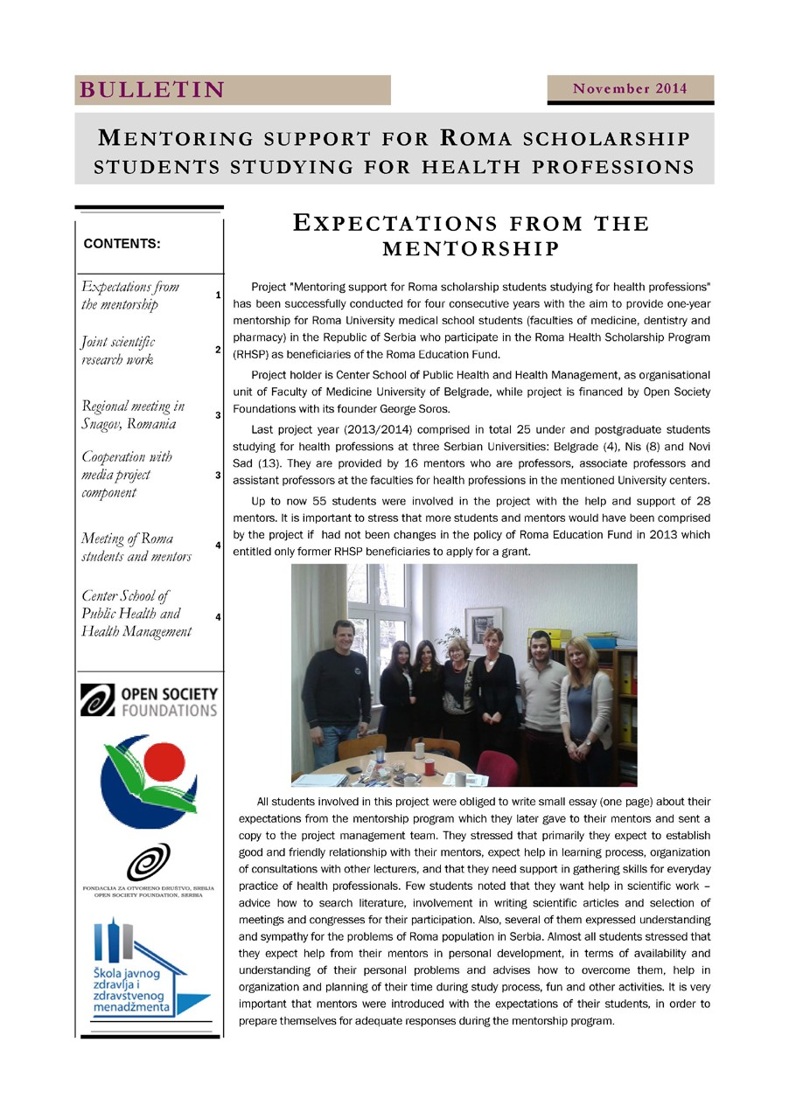
45

46
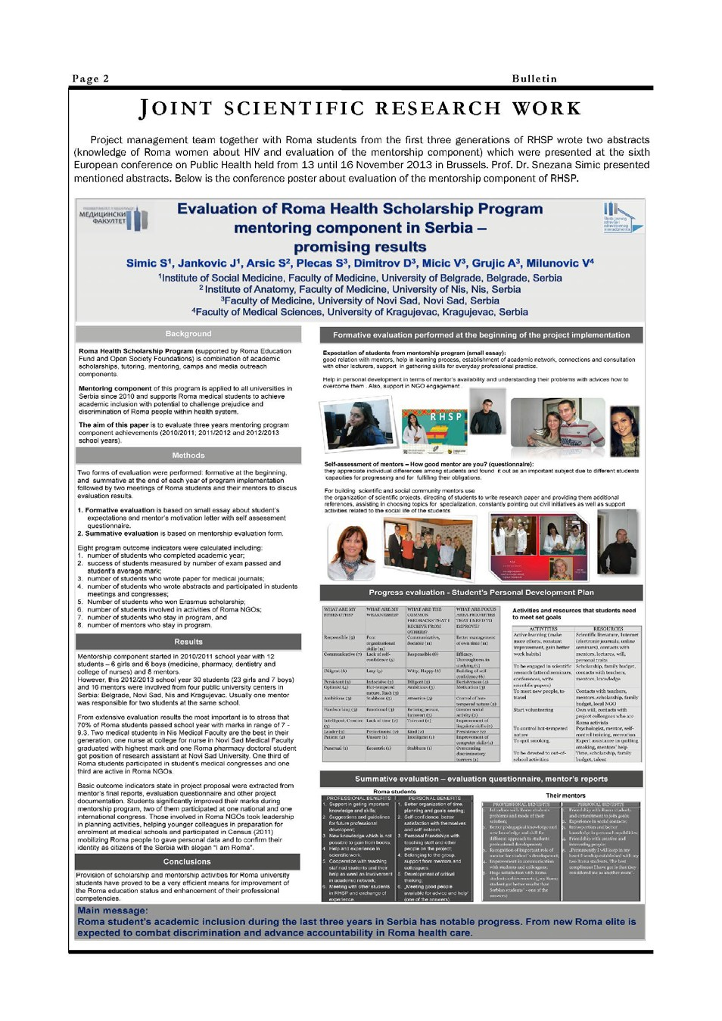

47
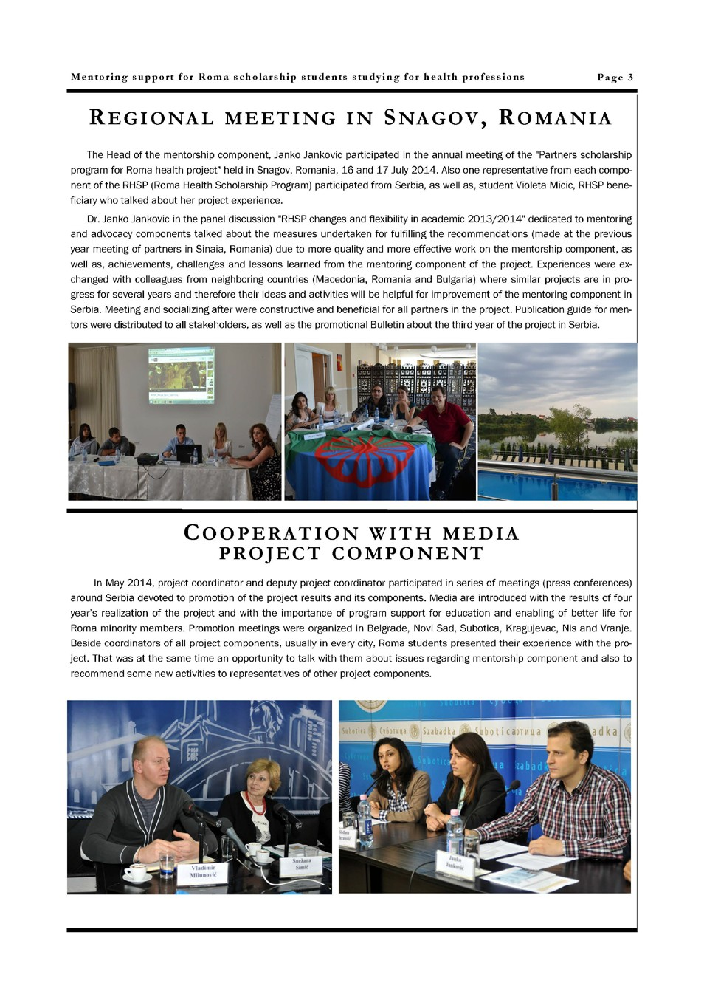

48
