School of Medicine Belgrade University
Center School of Public Health and Health Management

ROMA HEALTH PROJECT:

ROMA HEALTH SCHOLARSHIP PROGRAM – RHSP

MENTORSHIP COMPONENT

2012

The second year of the mentorship component of the Roma Health Scholarship Program supported by Roma Education Fund (REF) was started on 1st December 2011 and was completed on 30 November 2012. The whole project was implemented according to the project proposal approved by the Open Society Foundations. In total, 11 months (excluding one month summer holiday) of intensive work at four university schools of medicine in the Republic of Serbia (Belgrade, Novi Sad, Kragujevac and Niš) provided opportunity for Roma students for their better professional development and inclusion in academic community.
The general objective of this component was to provide one year mentorship program for Roma students preparing for health professions (medical doctor, pharmacist, dentist, nurse) at high educational institutions in Serbia. Only Roma students enrolled in Roma Health Scholarship Program were eligible for mentoring.
Specific objectives of the mentorship component were to:

• Provide support and help Roma student in professional and personal development;

• Support inclusion of Roma students in high school and social environment and realization of their right on education;
• Support Roma students in participation of health promotion programs devoted to Roma communities and in development of effective public health policies for Roma people.

ROMA STUDENTS IN THE MENTORING COMPONENT OF RHSP

In total 19 Roma students were involved in this project with 10 girls and 9 boys: two of them from School of Medicine Belgrade University, 10 of them from School of Medicine Novi Sad University, one from School of Medicine Kragujevac University and 6 of them from School of Medicine Niš University (Table 1).
Selection of students who received RHSP scholarship was completed in the middle of December 2011; out of 19 Roma students, six were from previous year and rest of them were new students in the mentorship component. According to the field of study: 13 were students of medicine, 2 students of farmacy, one student of stomatology and three of them were students of specialized education and nursing care at School of Medicine University of Novi Sad.
At the beginning of the work on the project, students were introduced to their mentors and together they carefully read and signed Rules of Procedure with their obligations (annex one on Serbian language). Necessity to introduce Rules of Procedures was appeared during the first year of the project implementation for better clarification of all important aspects and goals of the project to students and their mentors.
Usualy one mentor was allocated to two students at the same school according to project specifications. However, due to fact that only one student was from Kragujevac School of Medicine, he got one mentor to take care of him.

Student’s expectations from their mentors

All students involved in this project were obliged to write small essay (one page) about their expectations from the mentorship program. They stressed that primarily they expect to establish good and friendly relationship with their mentors, expect help in learning process, organization of consultations with other lecturers, and that they need support in gathering skills for everyday practice of health professionals. Five students noted that they want help in scientific work – advice how to search literature, involvement in writing scientific articles, availability of data-bases and selection of meeting and congresses for their participation. Almost all students stressed that they expect help in personal development from their mentors, in terms of availability and understanding of their personal problems and advises how to overcome those, help in organization and planning of their time during study process and good cooperation with
the mentors. They also wanted support from mentors in NGO sector involvement. Mentors were introduced with expectations of their students, in order to be prepared for adequate responses during the mentorship program.

Student’s Personal Development Plan - PDP

As in the first year of the project students were asked to make their own personal development plan (PDP) as a structured and continuous process that helps them to think about their own learning, performance and achievements and to plan for their personal, educational and career development. It is useful for students, as well as, for mentors. PDP presents a part of the professional portfolio or educational file of both students and mentors. The role of the mentor is to help students to make their own PDPs which they will later fill in and maintain (through their study and career).
The primary objective for PDP is to improve the capacity of students to understand what and how they are learning, and to review, plan and take responsibility for their own learning. Also it helps them to define goals and to evaluate progress in achieving those goals, to become more effective and independent in their work, to improve the learning skills and to pursue positive attitude towards learning, future education and career.
All 19 students which is a total number in the second year of the mentorship component of the project wrote their PDP.
PDP’s Template consists of 6 steps (annex 2), and these are: current state definition, desired state definition, activities and resources needed to achieve the desired state, timeline, implementation and evaluation.
As a first step in the PDP, students defined their current state (table 2), which was essential for measuring progress in the activities during the project life.
Regarding positive features, i.e. strengths, the students pointed out in the first place responsibility, than their communicational skills or friendliness. They also see themselves as diligent, persistent, hardworking, ambitious, intelligent young people full of optimism and with leadership skills. As for the weaknesses the most students emphasized on the first place poor organizational skills, than lack of self-confidence, laziness and indecisiveness. Some of the students identified as negative features that they are stubborn, perfectionists and they do not have
enough time to devote to out-of-school activities. Three of them said that they are hot-tempered and have stormy reactions. Concerning focus areas priorities on which they would like to work, i.e. to improve during the project life, in the first place is better management of their own time, than efficacy and thoroughness in studying, building of self-confidence and decisiveness, motivation, control of hot-tempered nature, greater social activity, improvement of linguistic and computer skills, as well as, overcoming discriminatory barriers (Table 2).

Table 2. Students’ current state

WHAT ARE MY STRENGTHS? | WHAT ARE MY WEAKNESSES? | WHAT ARE THE COMMON FEEDBACKS THAT I RECEIVE FROM OTHERS? | WHAT ARE FOCUS AREA PRIORITIES THAT I NEED TO IMPROVE?
Responsible (9)* | Poor  organizational skills (11) | Communicative,  Sociable (11) | Better management  of own time (11)
Communicative (7) | Lack of self-  confidence (5) | Responsible (8) | Efficacy,  Thoroughness in studying (7)
Diligent (6) | Lazy (5) | Witty, Happy (6) | Building of self-  confidence (6)
Persistent (5) | Indecisive (3) | Diligent (5) | Decisiveness (4)
Optimist (4) | Hot-tempered nature, Rash (3) | Ambitious (3) | Motivation (3)
Ambitious (3) | Stubborn (3) | Attentive (3) | Control of hot-  tempered nature (2)
Hardworking (3) | Emotional (3) | Retiring person,  Introvert (3) | Greater social  activity (2)
Intelligent, Creative  (3) | Lack of time (2) | Tolerant (2) | Improvement of  linguistic skills (2)
Leader (3) | Perfectionist (2) | Kind (2) | Persistence (2)
Patient (2) | Unsure (1) | Intelligent (1) | Improvement of  computer skills (1)
Punctual (1) | Eccentric (1) | Stubborn (1) | Overcoming  discriminatory barriers (1)
*Total number of students who stated specific feature
As a second step in the PDP, students were asked to say what they wish to achieve and why, i.e. what are their objectives in the project and later in the lifetime. The greatest number of students in the first place said they want to improve their knowledge, oral and practical skills, and to gain better work habits in order to manage their time and to plan their activities better, to be more efficient and more thorough in learning, to increase chances of getting the job, to be more successful and to have better social status. In the second place students underlined the desire to be more decisive, with more self-confidence in order to create new opportunities for success, to be more respected in the society and to be better contributors to the society. Some of them see themselves as members of non-governmental, student organizations through which they would like to promote the identity of the Roma people and to point out their marginalized position in the society, to meet new people and to travel in Europe and around the world. When it comes to control of students’ hot-tempered nature they believe that reckless decisions and actions would be avoidable in that way and consequently their loved ones and the people around them would not be hurt.
As a short-term goal, students would like at first place to pass remaining exams in the school year and to enroll in the next year, to be a little more occupied with out-of-school activities (learning languages, recreation and improving musical skills), to begin volunteer work in some of the student organizations, to travel and to have frequent meetings with mentor and with psychologist according to need. Medium-term goals are to: obtain a university degree, enroll in postgraduate studies (preferably abroad), qualify for work in practice, engage in scientific research work (projects, congresses, exchange of students and writing of scientific papers) and become Roma activist. Regarding long-term goals, students see themselves as proven experts and conscientious health professionals in their job or as a Head of some NGO organization focusing on the improvement of Roma health. Also, they would like to establish a stable family, to solve housing issue and to constantly improve themselves.
Methods for meeting the goals, i.e. activities and resources which are needed for students in order to achieve the desired state are shown in table 3.
This table clearly shows that students in the implementation of almost all activities recognize mentors’ help and see them as trustful personas which will help them to strengthen educational capacities due to better academic results, as well as personal and professional
development. They are aware that scholarship is of exceptional importance and without it they would not be able to accomplish the majority of planned activities due to limited family budget.

Table 3. Activities and resources that students need to meet set goals

ACTIVITIES | RESOURCES
Active learning (make more efforts,  constant improvement, gain better work habits) | Scientific literature, Internet (electronic  journals, online seminars), contacts with mentors, lectures, will, personal traits
To be engaged in scientific research  (attend seminars, conferences, write scientific papers) | Scholarship, family budget, contacts with  teachers, mentors, knowledge
To meet new people, to travel | Contacts with teachers, mentors, scholarship, family budget, local NGO
Start volunteering | Own will, contacts with project colleagues  who are Roma activists
To control hot-tempered nature | Psychologist, mentor, self-control training,  recreation
To quit smoking | Expert assistance in quitting smoking, mentors’ help
To be devoted to out-of-school activities | Time, scholarship, family budget, talent

Students also defined timelines for achieving the desired state i.e. for meeting their set goals at the start of the project. They have already met a lot of them, which can be seen in more detailed scope from mentors’ report.
Students began with the implementation of PDPs in May 2012

Roma students evaluation of the Mentorship component of RHSP

The mentorship component of the RHSP was evaluated by students and their mentors with evaluation questionnaire (annex 3). Questionnaire was same for students and their mentors enabling comparison of their answers and it consists of 12 questions devided in three groups. The first refers to commitment of mentors and students to the mentorship process, the second explores expectations, concerns and benefits gained from the whole program, and the third one is about meeting program objectives. Mentors and students were asked to complete questionnaire and return it to project coordinator and assistant project coordinator. They were asked also for suggestions and comments for improving the mentorship component of the program.
Goal of this evaluation was to ensure that the program is a meaningful venture, fulfilling expressed wants and needs of mentors and mentees who were involved in the mentorship component of the RHSP.
Until 10th of December 2012, four students were not fulfilled questionnaire, so in this

report only 15 out of 19 student’s evaluation were available for analysis.

The first group of questions related to time spent with mentor, the quality of meetings and the fact who initiated meeting. According to their personal assessment, students spent from one hour to 24 hours in average per month with their mentors, which was for whole group in average
6 to 7 hours in direct or indirect contacts (by phone or e-mail). They all stressed that this amount of time was enough for them, except one student who stressed that time he spent with mentor was not enough for him. Most frequently, initiative for contacts was from both sides, two students answered that it was on their initiative and one that initiative was from mentor side.
The second group of questions refers to expectations, concerns and benefits gained from the whole mentorship component of the program. Student’s expectations were already described, and in questionnaire they answered that they wanted help in gathering new knowledge and skills, advices about lectures and exams and consultations with other teaching staff. Then, students expected psychological support in solving the problem of anxiety from exams, more self- confidence and better adjustment to academic environment. Few students expected help in providing adequate literature, scientific work and support to work in non-governmental sector.
Most students have no concern about the mentorship program, although two students answered that they did not get adequate support from their mentor. Benefit gained from the program included both professional and personal aspects and they are listed in table 4.
Most important professional benefits for students were: support in getting knowledge and skills, help in learning process and improved efficiency of learning, additional consultations and contacts with professors and teaching staff and development of academic network.
As personal benefits from the mentorship program, students stressed support from their mentors, better organization of time, goals setting and planning, self-confidence and strengthening personal identity, maturation, responsibility, patience and advices how to deal with life and family problems.
There were no remarks on the mentorship component of RHSP and majority of students
stated that it was good project helping them to achieve better academic achievements, that is very well organized and managed and that respond to Roma student’s needs. However, two students were unsatisfied with their relationship with mentor and they stressed that mentors must be more involved in work with students and they suggested more control of mentor’s activities and their engagement in the project.

Table 4. Professional and personal benefits for Roma students

PROFESSIONAL BENEFITS | PERSONAL BENEFITS
1. Support in getting important knowledge  and skills;  2. Suggestions and guidelines for future professional development;  3. New knowledge which is not possible to gain from books;  4. Help and experience in scientific work;  5. Cooperation with teaching staff and students and their help as well as involvement in academic network;  6. Meeting with other students in RHSP  and exchange of experience. | 1. Better organization of time, planning  and goals setting;  2. Self-confidence, better satisfaction with themselves and self-esteem;  3. Personal friendships with teaching staff and other people on the project;  4. Belonging to the group, support from mentors and colleagues;  5. Development of critical thinking;  6. „Meeting good people available for advice and help“ (one of the answers).

According to opinion of Roma students, majority of goals of the mentorship component were achieved, particularly those related to professional development and knowledge gained as well as better contact with teaching staff and colleagues. Students’ opinion is that the program provided an opportunity for them to broader knowledge and contacts with colleagues and teachers, exposed them to different facets of practice in health care institutions and enhanced the process of career development. However, they think that program did not provide (sufficient) career strategy advice, so there is space for improvement in this aspect of mentorship program. Mentors’ opinion is that the program met all listed objectives except enough exposure of students to different facets of practice in health care institutions and this is something that the project has to improve together with mentors next year. Meeting the project objectives for Roma students are presented in table 5
Suggestions for mentorship component of RHSP improvements involved need for better control of some mentors, their higher involvement and motivation. Also, cooperation with
Ministry of Health and Ministry of Education was stressed, with distribution of information about program and his results. Students pledged for more Roma colleagues in the program due to the fact that evidence showed that project helped them for better achievements and adjustment to academic community.

Table 5. Meeting the mentorship program component objectives by Roma students

QUESTIONS | NOT AT ALL | SOME - WHAT | NEEDS IMPRO- VEMENTS | YES
In your experience, did the  program enhance the process of career development? |  | 3 |  | 12
Do you feel that the program assists in developing career coaching skills for the mentors who participate in the program? |  | 1 | 4 | 10
Did the program provide  (sufficient) career strategy advice to students? |  | 2 |  | 13
Did the program provide  You with a sense of professional growth and development? | 1 | 2 | 2 | 10
Did the program provide  You with an opportunity to broader your knowledge and contacts with colleagues and teachers? |  | 2 |  | 13
Did the program expose you  to different facets of practice in health care institutions? |  | 4 | 5 | 6

Notes and comments related to gratitude of Roma students to be part of this project including support they got from RHSP. Some students stressed that project gave them lot of wonderful things through friendship, participation in winter school, and help them and their families for easier study of very difficult, expensive and demanding health sciences.
MENTORS IN MENTORSHIP COMPONENT OF RHSP

Selection of suitable mentors was organized during December and the first half of January based on evaluation of their work in the first year for mentors where students expressed interest to continue collaboration, and for the new students, based on their whishes, communications with colleagues and Deans of medical schools (for some mentors formal permission from faculty administration was necessary for involvement in the project). Potential mentors filled application form with all important data which they send together with CV and short motivation letter. Desirable characteristic such as openness, willingness for cooperation and sensitivity to ethnic minority problems were basis for selection. There were ten new applications and four mentors from previous year. Ten mentors were selected for year 2012. In selection process, project coordinator, assistant project coordinator and national coordinator of RHSP were involved. Old mentors were started with work from the beginning of January, and new on the beginning of February. List of mentors included in the mentorship component was presented in
table 6.

One mentor from School of Medicine Belgrade University (assistant professor Zeljka Stanojevic) got postdoctoral scholarship in Hamburg and project coordinator and assistant project coordinator replaced her for the last two months.
Professor dr Boris Djindjic, mentor from School of Mediicne Nis University voluntarily accepted to work with Roma medical student Sasa Azirovic, who did not get scholarship but was willing to work with Dr. Djindjic. Project coordinator and assistant coordinator organized meeting with Roma students enrolled to School of Medicine Belgrade University based on affirmative measure of the Government of Serbia and offer them a help during their study, but only one girl accepted help and support.
During the whole period of project implementation, intensive contacts were undergone among students and their mentors. Mentors regularly reported about all project activities, first monthly, after that per three months, and at the end of the project they submitted final reports which were used also in the project evaluation. All mentor’s reports are part of project documentation (on Serbia language) and are available on request.
During summer holiday, from July 15th until August 15th was pause in the project implementation and mentors were not payed for the mentioned month of their work.
Self-assessment of mentors – “How good mentor are you?”

One of the mentor’s tasks on the beginning of project implementation was to fill out a self-assessment questionnaire about their work, i.e. to have an insight to what extent they are good mentors for their mentees (annex 4). All ten mentors who participated in the project fill out mentioned form. For each of 9 activities/strategies in self-assessment form, mentors were obliged to give an example from their practice which illustrates its use, as well as, to give suggestion for its improvement.
All answers were similar to previous year thoughts of mentors taking in account that four of them are experienced mentors from the previous year of the project. All of them stressed that they appreciate individual differences among students and found it out as an important subject
due to different students’ capacities for progressing and for fulfilling obligations. Mentors are available to their students at the faculties where face to face encounter can be easily arranged. Also, they can be reached by telephone, e-mail, and some of them through social networks, students’ forums or online consultations. If you asked mentors when was the last time they helped their students to accomplish desired goals, they replied that they did it often by advising their students to approach learning as a lifelong process, by providing them with continuous support, by helping them in writing scientific papers and by strengthening their self-confidence. For building a scientific and social community mentors use different measures and activities most of which are: the organization of scientific projects, directing of students to write research papers and providing them with additional references, assistance in choosing topics for specialization, doctoral dissertations, constantly pointing out civil initiatives as well as support activities related to the social life of the students.
Talking about the remaining strategies that mentors practice in their work, it is important to note that they often celebrate the success of their students and with some of them are still in contact, which represents a mentorship for life.

Mentors evaluation of the Mentorship component of RHSP

All mentors returned filled questionnaire by the 10th December 2012 and results of Roma students and mentors evaluation were presented at the final meeting held on 14th December 2012 at School of Medicine Belgrade University. The aim of this evaluation was confirmation that project justified money invested in professional and personal development of Roma health students.
Filled evaluation questionnaire with 12 questions was sent to project coordinator and assistant coordinator responsible for data analysis. It was mentioned to them that comments and suggestion are particularly valuable for project improvement.
The first group of questions related to time spent with student, the quality of meetings and the fact who initiated meeting. According to their documentation, they spent in average from
4 hours to 15 before students exams or seminars. In direct contacts this was one to two hours per week, and indirect contacts included addition time by phone or e-mail. All, except one mentor noted that this time was enough and adequate for student`s needs. Usualy meetings were
organized on both initiative; one mentor said that student had initiative and two mentors that it was on his initiative.
Mentor`s expectations from the mentorship component are following:

• The first group of answers related to mentor`s whishes for better relations with their students, better cooperation with them and at the same time, to use opportunity for more knowledge about themselves and dipper introduction with Roma students and colleagues, mentors in the mentorship component.
• The second group of answers related to help Roma students for better success in their studies, support with their experience and help in scientific activities. Also they stressed importance of their help in solving student`s personal problems and inspirations for better achievements in their academic life.
• The third group of answers related to possibility for development of sense of self- confidence in Roma students, and social inclusion and adaptation during the study process.
All mentors noted that their expectation from the project was fulfilled and that they have no remarks on project organization, management and implementation. Mentors mentioned introduction with creative and interesting young Roma people, better understanding of their own personal capacities to deal with problems of other people, personal satisfaction in establishment of good communication with good students and introduction of Roma culture, specificities and their status in the society, and as one mentor said, „this is a crown of my profession that allows me to be useful as a man“.
One group of questions in evaluation form included benefits from this project. Benefits were considered as professional and personal. The most important professional benefit was possibility to improve their pedagogical knowledge and skills during mentoring. Also, they wanted to introduce with cultural needs of Roma students. Considering benefits in personal development, they were related on friendship with Roma students and facts that providing help to Roma students they became better people and teachers (table 7).
Table 7. Professional and personal benefits for mentors

PROFESSIONAL BENEFITS | PERSONAL BENEFITS
1. Introduce with Roma students  problems and mode of their solution;  2. Better pedagogical knowledge and new knowledge and skill for different approach to students professional development;  3. Recognition of important role of mentor for student`s developemnt;  4. Improvement in communication with students and colleagues;  5. Huge satisfaction with Roma students achievemnets („my Roma student got better results than Serbian students“ - one of the answers) | 1. Friendship with Roma students and  commitment to join goals;  2. Experience in social contacts;  3. Introspection and better knowledge in personal capabilities;  4. Friendship with creative and interesting people;  5. „Permanently I will keep in my heart friendship established with my two Roma students. The best compliment I have got is that they considered me as another mum“.

Mentor`s opinion about meeting the project objectives was presented in table 8 according to mentors opinion, this component was very important for their development as teachers and all stressed that it helped them to improve knowledge, but also their contacts with other colleagues at schools. Involvement in this project was important for their career development, but also career development of their students bringing them responsibility to be good role model for them. However, like last year mentors` opinion is that the project met all listed objectives except enough exposure of students to different facets of practice in health care institutions, and students’ opinion is the same.
Many useful suggestions were given by mentors how to improve project performance. Following measures and activities are presented:
• Organization of meetings for experience and ideas exchange;

• Organization of workshops with students about topics they suggested as priority;

• Find a ways to support failed students who were in crisis and in that time the help is most important for them.
• Mentors should be from most difficult years of study on the beginning of undergraduate education because at that time students need strongest support and help;
• Suggestion to gather Roma health students in join scientific prorject or some
humanitarian activity or event;

• Providing financial support to Roma students’ projects selected on the basis of public announcement.

Table 8. Meeting the mentorship program component objectives by mentors

QUESTIONS | NOT AT ALL | SOME- WHAT | NEEDS IMPRO- VEMENTS | YES
In your experience, did the program enhance the process of career development? | 1 | 1 |  | 8
Do you feel that the program  assists in developing career coaching skills for the mentors who participate in the program? |  |  |  | 10
Did the program provide  (sufficient) career strategy advice to students? |  | 2 | 3 | 5
Did the program provide  you with a sense of professional growth and development? |  | 1 |  | 9
In your opinion, does the  program provide mentors with greater appreciation of their significance as role model? |  | 1 |  | 9
Did the program provide you with an opportunity to broader your knowledge and contacts with colleagues and teachers? |  | 2 | 1 | 7
Did the program expose you  to different facets of practice in health care institutions? | 2 | 2 | 2 | 4

Suggestion and comments from mentors related to the beginning of the school year program due to fact that in that case they can monitor student’s work better (it was also suggestion from last year) but unfortunately, this was not possible to realize because of duration of
student’s application and selection procedure. Mentors also suggested that they should work with Roma and other students voluntarily and they should include Roma students without scholarship, and that happened with some students in year 2012.
Mentors stated that program is excellent and offers Roma students better inclusion in educational system of the Republic of Serbia. Also, offers them opportunity to improve knowledge and skills for everyday practice, to be more self-confident and self-reliable, as well as, possibility for better valuation of themselves.

ACTIVITIES IMPLEMENTED IN MENTORSHIP COMPONENT OF THE RHSP DURING 2012
During the project implementation cooperation with other components of the RHSP –

advocacy component and media component was established and it was very close and successful. Also, participation at meetings and conferences related with RHSP activities was realized.

Organization of mentorship component meetings on the beginning and at the end of the project implementation
The first meeting of Roma students and their mentors was organized on 16th March in

the premises of main building, School of Medicine Nis University (Bulevar Zorana Đinđića 81, Niš). This was according to the suggestion from Roma students and mentors to change place of meetings and to allow other schools to provide hospitality for the project. All Roma students and mentors participated at meeting with project coordinator, assistant project coordinator and coordinator of RHSP in Serbia from Open Society Foundation Belgrade. Dean, Prof. Dr. Milan Višnjić and Prof. Dr. Boris Đinđić as representative of mentors from Nis University welcomed guests and expressed their satisfaction for possibility to participate in this program. Then, coordinator of RHSP in Serbia Jelena Savić made presentation about whole program, project coordinator Prof. Dr. Snezana Simić presentation about mentoring and role of mentors, and assistant project coordinator, Assistant Dr. Janko Janković introduced personal development plan concept and explained its importance for career development. Discussion was open about mode of work, expectations of Roma students from mentorship component and type of evaluation of
the whole program. Cocktail lunch for all participants was organized and informal contact lasted few hours more. All participants got folder with presentations, notebook and pencil (to write diary about project activities), as well as, CD with project proposal, evaluation form and other useful information. Also colleagues from media component of RHSP were present and the whole meeting was recorded on DVD.
The second meeting of Roma students and mentors was organized after project was completed, on 14th December, in the premises of Dean’s building, Scholl of Medicine Belgrade. Due to terrible weather conditions, only two mentors and 10 students participated. Vice-dean for continuous medical education and director of the Center School of Public Health and Health Management were with us to hear about project achievements and about students and mentors suggestions for improvements. Project coordinator, Prof. Simić made presentation about results of analysis of evaluation forms, and assistant project coordinator, assistant professor Janko Janković provided presentation with analysis of student’s personal development plans. Then, all mentors and students presented in short their experience with the project with particular focus on the quality of contacts they established with the students and on their achievement. Roma students also actively participated with their suggestions and ideas about future project activities. Some of them are not any more in project, but they stressed the quality of relation and friendship they established with their mentors. Those eligible for the next project were active with suggestions and ideas about new activities, mentors’ selection and program of winter school.
Roma students and mentors were introduced with Bulletin of the mentorship component (annex 5, only in Serbian language). Journalist from media component prepared one video report about mentorship component during the meeting and she also organized interviews with the students and mentors. Cocktail lunch was organized for all participants with informal communication and discussion afterwards.

Cooperation of Mentorship component with Advocacy component of the RHSP

In January 2012 Winter school „SASTO II – advocacy school for future Roma health professionals“ in Andrevlje, Fruska Gora, AP Vojvodina was organized by advocacy component of the RHSP. Majority of students and mentors participated, although because of regular duties at the end of semester, many of them did not. The first two days were devoted to mentoring and
project coordinator, assistant coordinator and one mentor presented their experience in the project and introduces new students and mentors with activities and tasks in mentorship component. Also, two Roma studnets – one from Novi Sad and one from Kragujevac presented their experience with mentorship component of the program.

Cooperation with medica component of the RHSP in 2012

In April and May, project coordinator and assistant project coordinator participated in series of meetings around Serbia devoted to promotion of the project by media component. So, promotion meetings were organized, as last year in Belgrade, than in Novi Sad, Subotica, Kragujevac, Nis and Vranje. Beside project coordinators, usually in every city, Roma students and their mentors presented their experience with the project. However, as a result of cooperation with media component two TV presentations and few newspaper articles were produces and they were available from the website of MEDIA Center Belgrade, as well as, leaflet and Bulletin of the mentorship component.

Meetings with RHSP partners in 2012

On 3rd and 4th April 2012, representatives of all components of RHSP from Serbia participated in Annual Meeting of Roma Health Scholarship Program partners: Taking stock of achievements and looking ahead. From mentorship component, representative was assistant project coordinator, Dr. Janko Jankovic. They had a chance to exchange experience with colleagues from Romania, Bulgaria and FYR of Macedonia, and to discuss issues relevant for the project implementation. New ideas and approaches learned from the meeting were applied in our project component.
At School of Medicine Pesc University (Hungary) was presented Roma Health Network (RomaHealthNet) on 25th October 2012. This network was developed as a project of RHSP and project coordinator was professor of infectious diseases Dr. Istvan Zilard with his team of young professionals. As a representative of mentorship component, Prof. Dr. Snezana Simic participated in this meeting and presented results of RHSP program.
BASIC PROJECT INDICATORS

All basic process and outcome indicators listed in the project proposal were selected from mentor’s reports submitted by mentors; some of them were selected from evaluation questionnaire filled out at the end of the project period by students and their mentors. Also, other project documentation – checklists, diaries, presentations were used for calculation of indicators (table 9)

Out of 19 Roma students in the mentorship component, 13 of them passed all exams and enrolled next year of study which is significant success of students and their mentors. Two students from Nis (brother and sister) have very high average mark (above 9 mark – range is from
6 to 10 in our medical schools) and they are excellent students according to their mentors opinion. Four students are very active in scientific work; one of them participated in students
international congress (held in Serbia) and three of them are in process of writing articles and they are going to apply for participation at scientific congress next year. Seven Roma students are involved in work with Roma non-governmental organization and students’ organization at their schools.
Values of indicators for monitoring mentorship component results are presented in table

10.

Table 10. Student’s success during mentorship component implementation in 2012

INDICATORS | VALUES
1. Number of students who completed academic year | 13 (two are at the last year of  study – VI; one student is preparing diploma written article.
2. Success of students measured by number of exams passed and average mark | In average passed four (4) exams (min 2 – max 7) Average mark in range  7.2 – 9.3
3. Number of students who wrote paper for medical journals | none
4. Number of students who wrote abstracts and participated  at students national and international congreses | One student from Nis  University, 3 prepare articles
5. Number of students with some activities for Roma people  or in Roma communities | Seven (7)
6. Number of students who won Erasmus scholarships | none
7. Number of students who will stay in program | Six (6) out of 19
8. Number of mentors who will stay in program | Four (4) out of 10

During this project year, leaflet for project promotion is printed on Serbian and English language (attached) and one Bulletin about project activities was also printed (only in Serbian language, attached to this report). In printing is publication „How to be a good mentor“written by teaching staff of Centre-School of Public Health and Health Management, School of Medicine Belgrade University – on Serbian language. This publication will be attached to this report in PDF version and printed version and available to mentors and other interested to learn more about mentoring process.
Suggestions for Mentorship component improvements

This report resulted with some lessons learned for project management team: The first one starts with reference how important mentoring is to those under mentors’ core responsibility. It is clear that mentors learnt how to provide superb support for the mentee under their charge. It was also clear that mentees had taken on board the behaviors of their mentors and were themselves on the right way to become the next generation of successful mentors. However, suggestions for mentorship component improvements include following:
1. Possibilities for more Roma students’ involvement in this component of RHSP because is useful for their professional development according to achieved results;
2. There is a need for more practical work and preparation for future career not only theoretical knowledge;
3. Students recommended introduction of mentor’s control which is accepted and measures are developed for telephone contacts and field visit;
4. Organization of humanitarian actions and activities in Roma communities which will involve Roma medical students and their mentors;
5. Letter to Deans of medical school in Serbia with mentorship component results description and achievements.

In conclusion

It is important for whole education system in Serbia to become more open to multicultural approaches and for people to accept the fact that by belonging to other nationality or to minority does not mean being exactly the same, having the same cultural differences, or having the same economic background as it stressed in position paper of the Roma Education Fund „Roma Inclusion in Education“ (2010). In September 2011, 185 Roma young people were enrolled at higher education schools in the Republic of Serbia. They were congratulated in the Parliament with massage that intention of Government is higher participation of Roma etnic minority in social, economical and political life of Serbia.
Whole RHSP and its mentorship component provide significant contribution to the process of Roma inclusion in high education. The impact of good mentor goes far beyond his or her own boundaries. With improvement of mentors’ skills and students’ compliance with this
component of RHSP, as well as, with wider promotion and acceptance of this program by Roma community, we can expect better participation and better results in coming years.

Annex 1.

KODEKS PONAŠANJA I RADA STUDENATA I MENTORA U PROJEKTU

„MENTORSKA PODRŠKA ROMIMA STIPENDISTIMA KOJI SE ŠKOLUJU ZA ZDRAVSTVENE PROFESIJE“

Ovim Kodeksom su definisane obaveze mentora i romskih studenata u projektu

„Mentorska podrška Romima stipendistima koji se školuju za zdravstvene profesije“ kao i mehanizmi arbitriranja u slučaju nesporazuma ili problema u radu. Mentor/mentorka će zajedno sa romskim studentima/studentkinjama svojeručnim potpisivanjem ovog dokumenta potvrditi da su upoznati sa obavezama i da će ih se pridržavati tokom trajanja projekta. Potpisan Kodeks bi trebalo vratiti rukovodiocima projekta (profesorki dr Snežani Simić i asistentu dr Janku Jankoviću).

1. Očekuje se da se tokom projekta mentor/mentorka viđa sa svojim studentima jednom nedeljno „licem u lice“ (4 do 6 puta mesečno), a da istovremeno održavaju i druge vidove komunikacije, telefonom ili imejlom. Tokom ovih konsultacija, oni razgovaraju o napredovanju studenta na studijama, pripremaju ih za polaganje ispita, kolokvijuma i seminara tako što im omogućavaju kontakte i sa drugim nastavnicima ili saradnicima u nastavi i rešavaju eventualne probleme koji mogu da se pojave tokom studija.
2. Odnos mentora/mentorki i romskih studenata/studentkinja je odnos pun razumevanja, poštovanja i uvažavanja međusobnih razlika. Studenti i mentori poštuju zakazano vreme konsultacija, kao i druge obaveze koje su preuzeli tokom međusobnog dogovora. Mentori i studenti su obavezi da redovno komuniciraju sa rukovodiocem projekta i zamenikom rukovodioca projekta (da odgovaraju na imejl poruke i/ili telefonske pozive).
3. Na samom početku projekta je potrebno da mentor popuni upitnik za samoprocenu “koliko sam dobar mentor“, da ga pošalje rukovodiocu projekta, kao i da radi na usavršavanju svojih mentorskih veština.
4. Od romskih studenata i studentkinja se očekuje da na početku projekta napišu kratak esej

(na jednoj strani) o svojim očekivanjima od ovog projekta.
5. Mentor/mentorka takođe ima obavezu da sa svojim studentima/studentkinjama u prvom mesecu rada na projektu formuliše personalni plan njihovog razvoja na osnovu formata koji je preporučen i usvojen u ovom projektu i koji će im biti dostavljen. Realizaciju ciljeva personalnog plana razvoja potom zajednički prate.
6. Mentor/mentorka pomaže studentima/studentkinjama ako su zainteresovani za naučno- istraživački rad tako što mu lično, ili u saradnji sa drugim kolegama, pomaže u izboru teme, pretraživanju literature, kritičkom čitanju literature i pisanju studentskih radova. Potrebno je romske studente i studentkinje stimulisati i motivisati da učestvuju na kongresima studenata medicine i stomatologije sa tim radovima ili da ih publikuju, da konkurišu za domaće i međunarodne stipendije, i da usavršavaju znanje jezika (posebno engleskog jezika).
7. Od mentora/mentorki se takođe očekuje da romske studente i studentkinje stimulišu da se angažuju u radu nevladinih organizacija, posebno onih koje se bave unapređenjem zdravlja Roma u Srbiji.
8. Svi mentori i svi studenti u ovom projektu imaju obavezu da prisustvuju i učestvuju u radu sastanaka koji će biti organizovani na početku projekta (prva nedelja marta meseca) i na kraju projekta (poslednja nedelja novembra meseca) na kojima će se razgovarati o načinu rada na projektu, dostignućima i problemima u radu. Posle prve polovine projekta, mentori/mentorske i romski studenti/studentkinje popunjavaju evaluacioni upitnik, kao i na završetku projekta. Tokom projekta će biti organizovan monitoring rada mentora/mentorki sa romskim studentima/studentkinjama.
9. U slučaju da se pojave problemi u radu mentora i romskih studenata, na zahtev studenta ili mentora može doći do promene mentora sa obrazloženjem zašto se to radi i nakon
pokušaja da se međusobni problemi ili nesporazumi reše.

Datum:
Svetlana Stojanović, studentkinja

Asis. dr Željka Stanojević, mentorka Damir Bahtijarević, student
Annex 2.

Personal Development Plan Template

What is my current state?
What are my strengths? | 1.  2.  3.
What are my weaknesses? | 1.  2.  3.
What are the common feedbacks that I receive from others | 1.  2.  3.
What are focus area priorities that I need to improve? | 1.  2.  3.
What is my desired state?
What do I want to improve? | 1.  2.  3.
Why do I need that? What does it give me? | 1.  2.  3.
What are my short-term goals (up to one year)? | 1.  2.  3.
What are my medium-term goals (2-5 years)? | 1.  2.  3.
What are my long-term goals (up to 10 years)? | 1.  2.  3.
What is needed to achieve desired state?
What activities do I need to take for achieving the goals? | 1.  2.  3

What are the possible resources for achieving the goals? | 1.  2.  3
Timeline
Schedule of activities | Focus area 1  Day and time:  Focus area 2  Day and time:  Focus area 3  Day and time:
Deadline for achieving the desired state? | Focus area 1  Start date:  Short-term goal: Medium-term goal:  Long-term goal:  Focus area 2  Start date:  Short-term goal: Medium-term goal: Long-term goal:  Focus area 3  Start date:  Short-term goal: Medium-term goal:  Long-term goal:
Notes/comments/suggestions/other

27
Annex 3

MENTOR / STUDENT EVALUATION FORM

To help RHE fund to maintain and improve the Mentorship component of the RHSP, we request that you complete and return the following program evaluation form.

This evaluation is being completed by the (check one):

а) Student b) Mentor

Name and surname (optional):

1. How much time, on average, per month has you spent with your mentor/student?

(in hours)

How was it spent?

2. Did this time commitment suit your needs?

YES NO

3. If answer is NO, it was: a) too long, or b) too short

4. Which one usually initiated the meetings?

а) Mentor b) Student c) Both equally

5. What expectations did you have from the program?
6. Have these expectations been met? YES NO

7. If answer is NO, way is that?

8. Do you have any concerns about the program? (Please give examples and explain)

9. What do you feel you have gained from this program?

а) professionally

б) personally

10. Please rank you answer for each question. Additional feedback is welcome and can be submitted on separate sheet provided at the end of this evaluation form.

QUESTION | NOT AT ALL | SOME- WHAT | NEEDS IMPROVEMENT | YES
1. In your experience, did the program
enhance the process of career development?
2. Do you feel that the program assists
in developing career coaching skills for the mentors who participate in the program?
3. Did the program provide (sufficient)
career strategy advice to students?
4. Did the program provide you with a
sense of professional growth and development?
5. In your opinion, does the program
provide mentors with a greater appreciation of their significance as a role model?
6. Did the program provide you with an
opportunity to broader your knowledge and contacts with colleagues and teachers?
7. Did the program expose you to
different facets of practice in health care institutions?

11. Please give suggestions on how to enhance the program.

12. Please add any additional comments you may have.

Thank you for your assistance!

Annex 4.

SELF-ASSESSMENT: How good mentor are you?

ACTIVITY /  STRATEGY | QUESTION / TASK | EXAMPLE | WHAT COULD BE DONE  BETTER?
Appreciate individual differences | Give an example of an incident that illustrates your acknowledgement of individual difference
Availability | Give an example of the strategy you  use to be available to your students/staff
Questioning | Describe how you last used active  questioning to lead a mentee towards solution
Building scientific  community | Describe a deliberate strategy you use  to build a scientific community in your group
Building social  community | Describe a deliberate strategy you use  to build your group as a social community
Celebration | When did you last celebrate a  student/staff member’s achievements? How did you celebrate?
Skill development | Describe steps you take to develop the  critical writing and presentation skills of your students/staff
Networking | Describe one example of how you have  introduced each of your students/staff into the scientific network of your research area
Mentor for life | How many of your past students/staff  are you contact with?

31
Annex 5. Mentorship component LIFLET

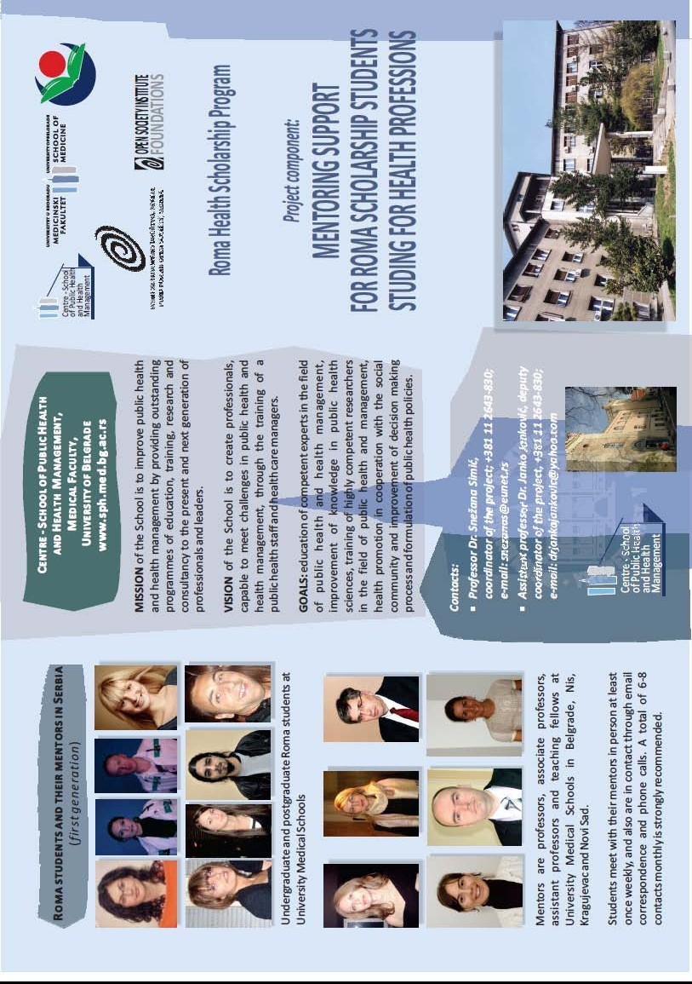

32

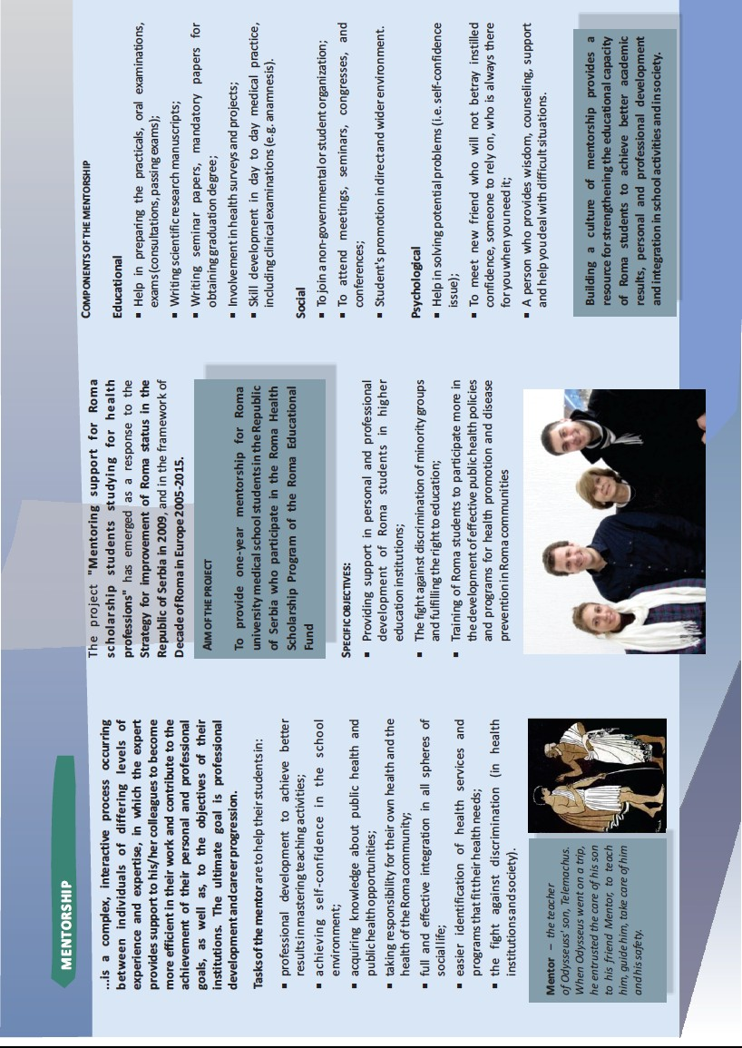

33
Annex 6. Bulletin of the Mentorship component of RHSP
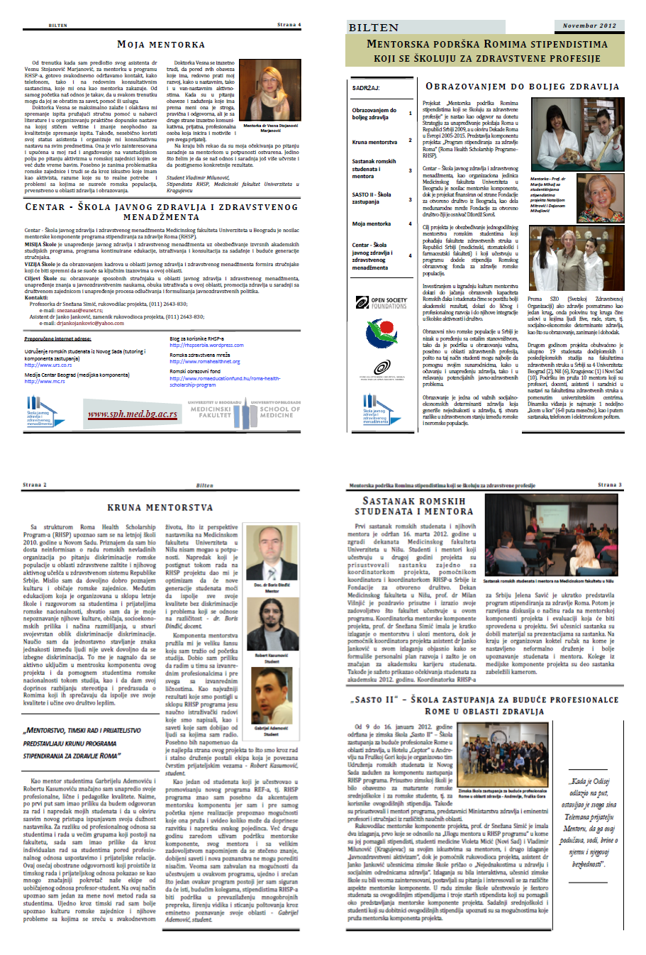
34

